AUTO DOCKING

PROJECT OVERVIEW

This project integrates pattern recognition, control logic and line extraction for a robotic system using the Robot Operating System (ROS2- Humble). It aims to enable a robot to autonomously navigate environments and perform docking operations by detecting patterns, making decisions based on these patterns, and accurately mapping surroundings using laser scan data.

OVERALL FLOW

**ROS 2 Launch System Setup (docking.py):**

* The auto-docking process is initiated through the ROS 2 launch system, defined in docking.py. Launch description includes setup for launching nodes related to laser line extraction, auto docking pattern detection and auto docking control.
* Generates a ‘LaunchDescription’ object (ld) with configured nodes and launch arguments.

**Laser Line Extraction (laser_line_extraction_node):**

* Purpose: Extracts lines from laser scan data to identify environmental features.
* Implementation: Implemented in ‘laser_line_extraction_node’ from ‘laser_line_extraction’ package. Parameters configured include frequency, frame ID (‘base_scan’), scan topic (‘scan;), and various line extraction thresholds.
* Input Information: Receives laser scan data (‘sensor_msgs/LaserScan messages’) from the robot's sensors.
* Output Information: Publishes line segments (‘laser_line_msgs/LineSegment messages’) and optionally visualization markers.

**Auto Docking Pattern Detection (‘pattern_node’):**

* Purpose: Detects specific patterns related to auto-docking, leveraging the extracted lines.
* Implementation: Implemented in ‘pattern_node’ from ‘auto_dock’ package. Parameters include angle and distance tolerances for pattern detection.
* Input Information: Receives line segments (‘laser_line_msgs/LineSegment’ messages) from ‘laser_line_extraction_node’.
* Output Information: Outputs detected patterns or relevant information about potential docking locations.

**Auto Docking Controller (‘controller_node’):**

* Purpose: Executes control logic to guide the robot to dock at the detected pattern.
* Implementation: Implemented in ‘controller_node’ from ‘auto_dock’ package. Controls robot's velocity and orientation based on relative positions and orientations to the docking pattern.
* Input Information: Receives information about the detected pattern (position and orientation) from ‘pattern_node’.
* Output Information: Sends velocity commands (‘geometry_msgs/Twist messages’) to drive the robot towards the docking location. Publishes status updates and logs regarding the docking process.

Data Flow:

* Laser scan data is processed by ‘laser_line_extraction_node’ to extract line segments.
* These segments are analyzed by ‘pattern_node’ to identify suitable docking patterns.

‘controller_node’ then uses this information to guide the robot towards the docking location.

COMPONENTS

**Pattern Recognition Module:**

* Detects specific patterns in sensor data, such as objects, landmarks, or conditions.
* Provides pattern indices or information to the control logic module.

**Control Logic Module:**

* Receives input from the pattern recognition module.
* Executes decision-making algorithms to control the robotic system's behavior based on detected patterns.
* Manages navigation, task execution, and responses to environmental changes.

**Line Extraction Module:**

* Processes laser scan data to detect and extract lines representing obstacles or features in the environment.
* Provides accurate geometric representations of detected lines for navigation and mapping purposes.

**Integration:**

* Utilizes ROS2 nodes for communication between modules.
* Publishes and subscribes to topics for exchanging sensor data, control commands, and line extraction results.
* Facilitates visualization and monitoring through ROS2 messages and visualization tools.

**Docking.py**

1. import os
2. from pathlib import Path
3. from ament_index_python.packages import get_package_share_directory
4. from launch import LaunchDescription
5. from launch.actions import DeclareLaunchArgument, IncludeLaunchDescription, ExecuteProcess
6. from launch.conditions import IfCondition
7. from launch.launch_description_sources import PythonLaunchDescriptionSource
8. from launch.substitutions import LaunchConfiguration
9. from launch_ros.actions import Node
10. from launch.actions import OpaqueFunction
11. def generate_launch_description():
12. # Declare launch arguments
13. declare_open_rviz_arg = DeclareLaunchArgument
14. ( 'open_rviz',
15. default_value='true',
16. description='Open RViz automatically’ )
17. open_rviz = LaunchConfiguration('open_rviz')
18. def launch_setup(context, *args, **kwargs):
19. # Conditional RViz node launch
20. rviz_node = Node
21. ( package='rviz2'
    1. executable='rviz2',
    2. name='rviz',
    3. arguments=['-d', os.path.join(get_package_share_directory('auto_dock'), 'rviz', 'rviz')],
    4. output='screen')
22. if open_rviz.perform(context) == 'true' else None
    1. return [
    2. # Uncomment this block if you need to use static_transform_publisher
    3. # ExecuteProcess(
    4. # cmd=['ros2', 'run', 'tf2_ros', 'static_transform_publisher', '0', '0', '0', '0', '0', '0', 'map'
    5. 'laser'],
    6. # output='screen'
    7. # )
23. # Node for laser line extraction
24. Node (
    1. package='laser_line_extraction',
    2. executable='laser_line_extraction_node',
    3. name='laser_line_extraction',
    4. output='screen',
    5. parameters= [{
    6. "frequency": 50.0,
    7. "frame_id": "base_scan",
    8. "scan_topic": "scan",
    9. "publish_markers": True,
    10. "bearing_std_dev": 0.0015,
    11. "range_std_dev": 0.01,
    12. "least_sq_angle_thresh": 0.0001,
        1. "least_sq_radius_thresh": 0.0001,
        2. "max_line_gap": 0.5,
        3. "min_line_length": 0.03,
        4. "min_range": 0.2,
        5. "min_split_dist": 0.05,
        6. "outlier_dist": 0.05,
        7. "min_line_points": 5,
    13. }]
    14. ),
25. # Node for auto docking pattern detection
    1. Node(
    2. package='auto_dock',
    3. executable='pattern',
    4. name='pattern_node',
    5. output='screen',
    6. parameters=[{
       1. "detect_angle_tolerance": 0.2,
       2. "group_dist_tolerance": 0.15,
       3. "laser_frame_id": "laser_frame",
    7. }]
    8. ),
26. #Node for auto docking controller

Node (

* + 1. package='auto_dock',
    2. executable='controller',
    3. name='controller_node',
    4. output='screen',
    5. parameters=[{
    6. "dist_to_dock": 0.22,
    7. "dist_to_center": 0.03,
    8. }]

),

1. # Node for TurtleBot3 navigation # Conditional RViz node

rviz_node

1. ]
2. # Launch description
3. ld = LaunchDescription([
4. declare_open_rviz_arg,
5. OpaqueFunction(function=launch_setup)
6. ])
7. return ld

**EXPLANATION**

* **(1-10)Imports**: Imports necessary modules and functions for handling launch configurations and ROS nodes.
* **(11)generate_launch_description() Function**:

**Launch Setup Function (launch_setup())**: This function is used to configure and return a list of nodes and processes to be launched based on the context provided.

**Conditional RViz Node**: Conditionally launches an RViz node (rviz_node) if open_rviz is set to 'true'. This node loads an RViz configuration file located in the auto_dock package directory.

* **Nodes**:

**(24)Laser Line Extraction Node**: Launches a node (laser_line_extraction_node) from the laser_line_extraction package, which extracts lines from laser scan data. It is configured with various parameters related to line extraction.

**(25) Docking Pattern Detection Node**: Launches a node (pattern_node) from the auto_dock package, responsible for detecting patterns related to auto docking. It is configured with parameters such as detect_angle_tolerance, group_dist_tolerance, and laser_frame_id.

**(26)Auto Docking Controller Node**: Launches a node (controller_node) from the auto_dock package, which controls the auto docking process. It is configured with parameters like dist_to_dock and dist_to_center.

* **(30)Launch Description (ld)**: Constructs a LaunchDescription object containing The declare_open_rviz_arg launch argument declaration. An Opaque Function that executes launch_setup() to gather all configured nodes and processes.

### **Output :** This script outputs a LaunchDescription object (ld) that defines the entire launch configuration for launching nodes related to laser line extraction, auto docking pattern detection, and auto docking control. Launches nodes for laser line extraction (laser_line_extraction_node), auto docking pattern detection (pattern_node), and auto docking controller (controller_node).

**line_extraction_node.cpp**

It is the main entry point and class definition for a ROS 2 node that performs line extraction from laser scan data.

**Line_extraction_node.h**

1. #ifndef LINE_EXTRACTION_ROS_H
2. #define LINE_EXTRACTION_ROS_H
3. #include <vector>
4. #include <string>
5. #include "rclcpp/rclcpp.hpp"
6. #include "sensor_msgs/msg/laser_scan.hpp"
7. #include "visualization_msgs/msg/marker.hpp"
8. #include "geometry_msgs/msg/point.hpp"
9. #include "laser_line_msgs/msg/line_segment_list.hpp"
10. #include "laser_line_msgs/msg/line_segment.hpp"
11. #include "line.h"
12. #include "line_extraction.h"
13. namespace line_extraction
14. {
15. class LineExtractionROS : public rclcpp::Node
16. {
17. public:
    1. LineExtractionROS(): Node("line_extraction")
    2. {
    3. // Parameters used by this node
    4. this->declare_parameter<bool>("data_cached", false);
    5. this->get_parameter("data_cached", data_cached_);
    6. this->declare_parameter<std::string>("frame_id", "base_scan");
    7. this->get_parameter("frame_id", frame_id_);
    8. RCLCPP_INFO(this->get_logger(), "[%s] frame_id = %s", __func__, frame_id_.c_str());
    9. this->declare_parameter<std::string>("scan_topic", "scan");
    10. this->get_parameter("scan_topic", scan_topic_);
    11. RCLCPP_INFO(this->get_logger(), "[%s] scan_topic = %s", __func__, scan_topic_.c_str());
    12. this->declare_parameter<bool>("publish_markers", true);
    13. this->get_parameter("publish_markers", pub_markers_);
    14. RCLCPP_INFO(this->get_logger(), "[%s] publish_markers = %d", __func__, pub_markers_);
    15. // this->declare_parameter<float>("frequency", 1.0);
    16. // this->get_parameter("frequency", frequency_);
    17. // RCLCPP_INFO(this->get_logger(), "[%s] frequency = %f", __func__, frequency_);
    18. // Parameters used by the line extraction algorithm
    19. this->declare_parameter<double>("bearing_std_dev", 1e-3);
    20. this->get_parameter("bearing_std_dev", bearing_std_dev);
    21. RCLCPP_INFO(this->get_logger(), "[%s] bearing_std_dev = %f", __func__, bearing_std_dev);
    22. this->declare_parameter<double>("range_std_dev", 0.02);
    23. this->get_parameter("range_std_dev", range_std_dev);
    24. RCLCPP_INFO(this->get_logger(), "[%s] range_std_dev = %f", __func__, range_std_dev);
    25. this->declare_parameter<double>("least_sq_angle_thresh", 1e-4);
    26. this->get_parameter("least_sq_angle_thresh", least_sq_angle_thresh);
    27. RCLCPP_INFO(this->get_logger(), "[%s] least_sq_angle_thresh = %f", __func__, least_sq_angle_thresh);
    28. this->declare_parameter<double>("least_sq_radius_thresh", 1e-4);
    29. this->get_parameter("least_sq_radius_thresh", least_sq_radius_thresh);
    30. RCLCPP_INFO(this->get_logger(), "[%s] least_sq_radius_thresh = %f", __func__, least_sq_radius_thresh);
    31. this->declare_parameter<double>("max_line_gap", 0.4);
    32. this->get_parameter("max_line_gap", max_line_gap);
    33. RCLCPP_INFO(this->get_logger(), "[%s] max_line_gap = %f", __func__, max_line_gap);
    34. this->declare_parameter<double>("min_line_length", 0.03);
    35. this->get_parameter("min_line_length", min_line_length);
    36. RCLCPP_INFO(this->get_logger(), "[%s] min_line_length = %f", __func__, min_line_length);
    37. this->declare_parameter<double>("min_range", 0.4);
    38. this->get_parameter("min_range", min_range);
    39. RCLCPP_INFO(this->get_logger(), "[%s] min_range = %f", __func__, min_range);
    40. this->declare_parameter<double>("min_split_dist", 0.05);
    41. this->get_parameter("min_split_dist", min_split_dist);
    42. RCLCPP_INFO(this->get_logger(), "[%s] min_split_dist = %f", __func__, min_split_dist);
    43. this->declare_parameter<double>("outlier_dist", 0.05);
    44. this->get_parameter("outlier_dist", outlier_dist);
    45. RCLCPP_INFO(this->get_logger(), "[%s] outlier_dist = %f", __func__, outlier_dist);
    46. this->declare_parameter<int>("min_line_points", 5);
    47. this->get_parameter("min_line_points", min_line_points);
    48. RCLCPP_INFO(this->get_logger(), "[%s] min_line_points = %d", __func__, min_line_points);
    49. scan_subscriber_ = this->create_subscription<sensor_msgs::msg::LaserScan>(scan_topic_, rclcpp::QoS(rclcpp::KeepLast(10)).best_effort().durability_volatile(), std::bind(&LineExtractionROS::scan_cb, this, std::placeholders::_1));
    50. line_publisher_ = this->create_publisher<laser_line_msgs::msg::LineSegmentList>("line_segments", 1);
    51. marker_publisher_ = this->create_publisher<visualization_msgs::msg::Marker>("line_markers", 1)
18. }
19. void run();
20. private:
    1. LineExtraction line_extraction_;
    2. bool data_cached_, pub_markers_;
    3. std::string frame_id_;
    4. std::string scan_topic_;
    5. // float frequency_;
    6. double bearing_std_dev, range_std_dev, least_sq_angle_thresh, least_sq_radius_thresh, max_line_gap, min_line_length, min_range, min_split_dist, outlier_dist;
    7. int min_line_points;
    8. void populateLineSegListMsg(const std::vector<Line>&, laser_line_msgs::msg::LineSegmentList&);
    9. void populateMarkerMsg(const std::vector<Line>&, visualization_msgs::msg::Marker&);
    10. void scan_cb(const sensor_msgs::msg::LaserScan::SharedPtr scan);
    11. void CachedData(const sensor_msgs::msg::LaserScan::SharedPtr scan);
    12. rclcpp::Subscription<sensor_msgs::msg::LaserScan>::SharedPtr scan_subscriber_;
    13. rclcpp::Publisher<laser_line_msgs::msg::LineSegmentList>::SharedPtr line_publisher_;
    14. rclcpp::Publisher<visualization_msgs::msg::Marker>::SharedPtr marker_publisher_;
21. };
22. }
23. #endif

**EXPLANATION**

* (3-12)Includes necessary headers: Includes standard library headers and ROS 2 message headers.
* (13)Namespace line_extraction: Defines a namespace to avoid name conflicts.
* (15)Class definition: Defines the LineExtractionROS class

**LineExtractionROS Class** :

* + Constructor: Declares and retrieves parameters, sets up subscriptions and publishers.
  + Parameters: Includes various parameters for the line extraction algorithm and node configuration.
  + Subscriptions: Subscribes to the scan topic to receive sensor_msgs::msg::LaserScan messages.
  + Publishers: Publishes extracted line segments and markers.

**Member Functions:**

* + run(): Main loop for running the line extraction process.
  + populateLineSegListMsg(): Populates a LineSegmentList message with extracted lines.
  + populateMarkerMsg(): Populates a Marker message for visualization.
  + scan_cb(): Callback for processing incoming laser scan messages.
  + CachedData(): Caches incoming laser scan data if required.
  + Private members: Defines private member variables and methods for internal use.

**line_extraction_node.cpp**

1. #include "laser_line_extraction/line_extraction_node.h"
2. int main(int argc, char* argv[])
3. {
4. std::shared_ptr<line_extraction::LineExtractionROS> line_extraction_node;
5. rclcpp::init(argc, argv);
6. line_extraction_node = std::make_shared<line_extraction::LineExtractionROS>();
7. RCLCPP_INFO(line_extraction_node->get_logger(), "[%s] line_extraction_node has been started", __func__);
8. rclcpp::WallRate rate(50.0);
9. while (rclcpp::ok())
10. {
11. line_extraction_node->run();
12. rclcpp::spin_some(line_extraction_node);
13. rate.sleep();
14. }
15. return 0; }

**FLOW**

* Initialization: The node is initialized, parameters are declared and retrieved, and subscriptions and publishers are set up.
* Main Loop: The node enters a loop where it continuously processes incoming laser scan data to extract lines and publish the results.

**EXPLANATION**

Main Function: Initializes the ROS 2 environment and the LineExtractionROS node.Starts the node and processes callbacks in a loop. Entry point of the program.

* (1)Includes the header file: line_extraction_node.h is included to use LineExtractionROS class.
* (5)ROS 2 initialization: Initializes the ROS 2 client library.
* (6)Create node instance: Creates an instance of the LineExtractionROS class.
* (7)Log start message: Logs that the node has started.
* (8)Loop rate: Sets the rate at which the loop runs (50 Hz).
* (9)Main loop: Continuously calls the run method, processes incoming messages, and sleeps to maintain the loop rate**.**

**Input**

Laser scan data: Subscribed from a ROS 2 topic (e.g., scan_topic_).

**Output**

Line segments: Published to a ROS 2 topic (e.g., line_segments).

Markers: Published to a ROS 2 topic (e.g., line_markers).

This structure allows the node to process incoming laser scan data, extract line segments, and publish the results for other nodes to us

Pattern Angle Definition

### 

Pattern Parameters Definition

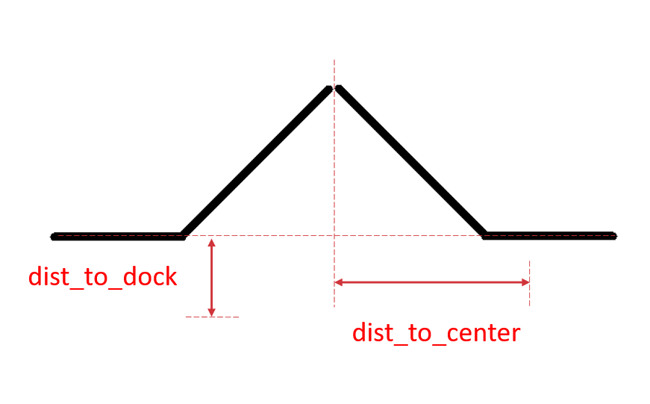

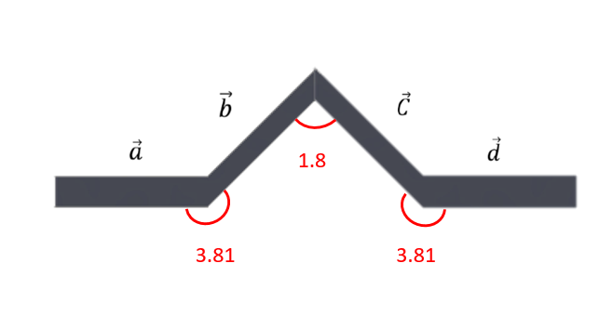

**pattern_angle1**

Theta 1 as shown in pattern angle definition. Note that the unit is radian.

**pattern_angle2**

Theta 2 as shown in pattern angle definition. Note that the unit is radian.

**pattern_angle3**

Theta 3 as shown in pattern angle definition. Note that the unit is radian.

**detect_angle_tolerance**

The maximum difference between detected angle and pattern angle(pattern_angle1, pattern_angle2, pattern_angle3)

**group_dist_tolerance**

The maximum distance between two line to be recognize as a part of pattern. Such as the distance between the end point of detected vector b and the start point of detected vector a should smaller than group_dist_tolerance to be consider as a part of pattern.

**laser_frame_id**

The laser frame of the robot.

**base_frame_id**

The base frame of the robot.

**min_v**

Minimum linear velocity of the robot.

**min_w**

Minimum angular velocity of the robot.

**max_v**

Maximum linear velocity of the robot.

**max_w**

Maximum angular velocity of the robot.

**threshold_v**

The threshold of changing between minimum and maximum linear velocity.

**threshold_w**

The threshold of changing between minimum and maximum angular velocity.

**dist_to_dock**

Distance to the dock frame.

**dist_to_center**

Distance to the center.

**CHISQUARED DISTANCE**

* Statistical measure used to assess the dissimilarities between two probability distribution
* Computed based on observed and expected frequency
* Used to show dissimilarities between lines
* It is crucial in deciding whether the lines should merge or not based on similarities and dissimilarities
* Below threshold - merge , Above threshold – doesn’t merge

**EUCLIDEAN DISTANCE**

* Straight line distance between 2 points space
* Represent length of shortest path connecting them
* Used to find the separation between points

**line_extraction.cpp**

The LineExtraction class is responsible for extracting lines from laser scan data using various filtering, splitting, merging, and fitting techniques. **line_extraction.h**: Defines the LineExtraction class with methods for setting parameters and extracting lines from laser scan data. Includes necessary libraries and dependencies. **line_extraction.cpp**: Implements methods to set parameters and perform line extraction algorithms.

**line_extraction.h**

1. #ifndef LINE_EXTRACTION_H
2. #define LINE_EXTRACTION_H
3. #include <cmath>
4. #include <vector>
5. #include <boost/array.hpp>
6. #include <eigen3/Eigen/Dense>
7. #include "utilities.h"
8. #include "line.h"
9. namespace line_extraction
10. {
11. class LineExtraction
12. {
13. public:
14. // Constructor / destructor
15. LineExtraction();
16. ~LineExtraction();
17. // Run
18. void extractLines(std::vector<Line>&);
19. // Data setting
20. void setCachedData(const std::vector<double>&, const std::vector<double>&,
    * 1. const std::vector<double>&, const std::vector<unsigned int>&);
21. void setRangeData(const std::vector<double>&);
22. // Parameter setting
23. void setBearingVariance(double);
24. void setRangeVariance(double);
25. void setLeastSqAngleThresh(double);
26. void setLeastSqRadiusThresh(double);
27. void setMaxLineGap(double);
28. void setMinLineLength(double);
29. void setMinLinePoints(unsigned int);
30. void setMinRange(double);
31. void setMinSplitDist(double);
32. void setOutlierDist(double);
33. private:
34. // Data structures
35. CachedData c_data_;
36. RangeData r_data_;
37. Params params_;
38. // Indices after filtering
39. std::vector<unsigned int> filtered_indices_;
40. // Line data
41. std::vector<Line> lines_;
42. // Methods
43. double chiSquared(const Eigen::Vector2d&, const Eigen::Matrix2d&,
    * 1. const Eigen::Matrix2d&);
44. double distBetweenPoints(unsigned int index_1, unsigned int index_2);
45. void filterClosePoints();
46. void filterOutlierPoints();
47. void filterLines();
48. void mergeLines();
49. void split(const std::vector<unsigned int>&);
50. };
51. } // namespace line_extraction
52. #endif

**Explanation**

* (15-16)Constructor and Destructor: Initialize and clean up resources.
* (18)extractLines: Main method to extract lines from data.
* (20-21)Data Setting Methods: Set cached and range data required for processing.
* (23-32)Parameter Setting Methods: Set parameters controlling the line extraction process.
* (33-41)Private Members: Store cached data, range data, parameters, filtered indices, and extracted lines.
* (43-49)Private Members: Internal methods for calculations, filtering, and line processing.

**Input and Output Information**

Input:

* Cached data and range data from sensors.
* Various parameters set by the user or configuration.

Output:

* Extracted lines stored in a vector of Line objects.

This header file defines the interface and private members of the LineExtraction class, which is responsible for extracting lines from sensor data, a critical step in the auto-docking process.

**auto_dock.h**

1. #include <boost/array.hpp>
2. #include <iostream>
3. #include <cmath>
4. //distance function for middle point array
5. double dist( auto vector_i , auto vector_j){
6. float dist = sqrt(pow(fabs(vector_i[0] - vector_j[0]),2)+pow(fabs(vector_i[1] - vector_j[1]),2));
7. return dist;
8. }
9. //translate line vector to middle point array
10. auto mid_point(auto vector){
11. boost::array<double, 2> mid ;
12. mid[0] = (vector.start[0]+vector.end[0])/2 ;
13. mid[1] = (vector.start[1]+vector.end[1])/2 ;
14. return mid;
15. }
16. //middle point between two middle point array
17. auto mid_two_point( auto array_a , auto array_b){
18. boost::array<double, 2> mid ;
19. mid[0] = (array_a[0] + array_b[0])/2 ;
20. mid[1] = (array_a[1] + array_b[1])/2 ;
21. return mid;
22. }
23. //distance function for two line vector
24. double mid_dist( auto vector_i , auto vector_j){
25. boost::array<double, 2> mid_i = mid_point(vector_i);
26. boost::array<double, 2> mid_j = mid_point(vector_j);
27. double dist = sqrt(pow(fabs(mid_i[0] - mid_j[0]),2)+pow(fabs(mid_i[1] - mid_j[1]),2));
28. return dist;
29. }

**Explanation**

* (1-3)Includes: Include necessary headers for arrays, input/output operations, and mathematical functions.
* (5-7)Distance Function for Middle Point Array : Calculate the Euclidean distance between two 2D points.**Inputs**: auto vector_i, auto vector_j 2D points represented as arrays.**Outputs**: Distance between the points.
* (10-14)Translate Line Vector to Middle Point Array: Calculate the midpoint of a line segment. **Inputs**: auto vector: A line segment with start and end points. **Outputs**: boost::array<double, 2>: Midpoint of the line segment.
* (17-21)Middle Point Between Two Middle Point Arrays: Calculate the midpoint between two midpoints. **Inputs**: auto array_a, auto array_b: 2D midpoints represented as arrays.**Outputs**: boost::array<double, 2>: Midpoint between the two given midpoints
* (24-28)Distance Function for Two Line Vectors: Calculate the distance between the midpoints of two line segments. **Inputs**: auto vector_i, auto vector_j: Two line segments.

**Outputs**: Distance between the midpoints of the two line segments.

**Usage of auto_dock.h in line_extraction.cpp**

* The auto_dock.h utilities provide additional tools for calculating distances and midpoints, which can enhance the line merging and splitting processes in the LineExtraction class.
* They can be integrated into the mergeLines and split methods to refine the criteria used for line segmentation and merging, leading to more accurate line extraction and better performance in an auto-docking system.

**line_extraction.cpp**

1. #include "laser_line_extraction/line_extraction.h"
2. #include <algorithm>
3. #include <eigen3/Eigen/Dense>
4. #include <iostream>
5. namespace line_extraction
6. {
7. ///////////////////////////////////////////////////////////////////////////////
8. // Constructor / destructor
9. ///////////////////////////////////////////////////////////////////////////////
10. LineExtraction::LineExtraction()
11. {
12. }
13. LineExtraction::~LineExtraction()
14. {
15. }
16. ///////////////////////////////////////////////////////////////////////////////
17. // Main run function
18. ///////////////////////////////////////////////////////////////////////////////
19. void LineExtraction::extractLines(std::vector<Line>& lines)
20. {
21. // Resets
22. filtered_indices_ = c_data_.indices;
23. lines_.clear();
24. // Filter indices
25. filterClosePoints();
26. filterOutlierPoints();
27. // Return no lines if not enough points left
28. // std::cout << params_.min_line_points << std::endl;
29. if (filtered_indices_.size() <= std::max(params_.min_line_points, static_cast<unsigned int>(3)))
30. {
31. return;
32. }
33. // Split indices into lines and filter out short and sparse lines
34. split(filtered_indices_);
35. filterLines();
36. // Fit each line using least squares and merge colinear lines
37. for (std::vector<Line>::iterator it = lines_.begin(); it != lines_.end(); ++it)
38. {
39. it->leastSqFit();
40. }
41. // If there is more than one line, check if lines should be merged based on the merging criteria
42. if (lines_.size() > 1)
43. {
44. mergeLines();
45. }
46. lines = lines_;
47. // std::cout << lines.size() << std::endl;
48. }
49. ///////////////////////////////////////////////////////////////////////////////
50. // Data setting
51. ///////////////////////////////////////////////////////////////////////////////
52. void LineExtraction::setCachedData(const std::vector<double>& bearings,
    * + 1. const std::vector<double>& cos_bearings,
        2. const std::vector<double>& sin_bearings,
        3. const std::vector<unsigned int>& indices)
53. {
54. c_data_.bearings = bearings;
55. c_data_.cos_bearings = cos_bearings;
56. c_data_.sin_bearings = sin_bearings;
57. c_data_.indices = indices;
58. }
59. void LineExtraction::setRangeData(const std::vector<double>& ranges)
60. {
61. r_data_.ranges = ranges;
62. r_data_.xs.clear();
63. r_data_.ys.clear();
64. for (std::vector<unsigned int>::const_iterator cit = c_data_.indices.begin();
65. cit != c_data_.indices.end(); ++cit)
66. {
67. r_data_.xs.push_back(c_data_.cos_bearings[*cit] * ranges[*cit]);
68. r_data_.ys.push_back(c_data_.sin_bearings[*cit] * ranges[*cit]);
69. }
70. }
71. ///////////////////////////////////////////////////////////////////////////////
72. // Parameter setting
73. ///////////////////////////////////////////////////////////////////////////////
74. void LineExtraction::setBearingVariance(double value)
75. {
76. params_.bearing_var = value;
77. }
78. void LineExtraction::setRangeVariance(double value)
79. {
80. params_.range_var = value;
81. }
82. void LineExtraction::setLeastSqAngleThresh(double value)
83. {
84. params_.least_sq_angle_thresh = value;
85. }
86. void LineExtraction::setLeastSqRadiusThresh(double value)
87. {
88. params_.least_sq_radius_thresh = value;
89. }
90. void LineExtraction::setMaxLineGap(double value)
91. {
92. params_.max_line_gap = value;
93. }
94. void LineExtraction::setMinLineLength(double value)
95. {
96. params_.min_line_length = value;
97. }
98. void LineExtraction::setMinLinePoints(unsigned int value)
99. {
100. params_.min_line_points = value;
101. }
102. void LineExtraction::setMinRange(double value)
103. {
104. params_.min_range = value;
105. }
106. void LineExtraction::setMinSplitDist(double value)
107. {
108. params_.min_split_dist = value;
109. }
110. void LineExtraction::setOutlierDist(double value)
111. {
112. params_.outlier_dist = value;
113. }
114. ///////////////////////////////////////////////////////////////////////////////
115. // Utility methods
116. ///////////////////////////////////////////////////////////////////////////////
117. double LineExtraction::chiSquared(const Eigen::Vector2d &dL, const Eigen::Matrix2d &P_1,const Eigen::Matrix2d &P_2)
118. {
119. return dL.transpose() * (P_1 + P_2).inverse() * dL;
120. }
121. double LineExtraction::distBetweenPoints(unsigned int index_1, unsigned int index_2)
122. {
123. return sqrt(pow(r_data_.xs[index_1] - r_data_.xs[index_2], 2) +

pow(r_data_.ys[index_1] - r_data_.ys[index_2], 2));

1. }
2. ///////////////////////////////////////////////////////////////////////////////
3. // Filtering points
4. ///////////////////////////////////////////////////////////////////////////////
5. void LineExtraction::filterClosePoints()
6. {
7. std::vector<unsigned int> output;
8. for (std::vector<unsigned int>::const_iterator cit = filtered_indices_.begin();
9. cit != filtered_indices_.end(); ++cit)
10. {
11. if (r_data_.ranges[*cit] >= params_.min_range)
12. {
13. output.push_back(*cit);
14. }
15. }
16. filtered_indices_ = output;
17. }
18. void LineExtraction::filterOutlierPoints()
19. {
20. if (filtered_indices_.size() < 3)
21. {
22. return;
23. }
24. std::vector<unsigned int> output;
25. unsigned int p_i, p_j, p_k;
26. for (std::size_t i = 0; i < filtered_indices_.size(); ++i)
27. {
28. // Get two closest neighbours
29. p_i = filtered_indices_[i];
30. if (i == 0) // first point
31. {
32. p_j = filtered_indices_[i + 1];
33. p_k = filtered_indices_[i + 2];
34. }
35. else if (i == filtered_indices_.size() - 1) // last point
36. {
37. p_j = filtered_indices_[i - 1];
38. p_k = filtered_indices_[i - 2];
39. }
40. else // middle points
41. {
42. p_j = filtered_indices_[i - 1];
43. p_k = filtered_indices_[i + 1];
44. }
45. // Check if point is an outlier
46. if (fabs(r_data_.ranges[p_i] - r_data_.ranges[p_j]) > params_.outlier_dist &&
47. fabs(r_data_.ranges[p_i] - r_data_.ranges[p_k]) > params_.outlier_dist)
48. {
49. // Check if it is close to line connecting its neighbours
50. std::vector<unsigned int> line_indices;
51. line_indices.push_back(p_j);
52. line_indices.push_back(p_k);
53. Line line(c_data_, r_data_, params_, line_indices);
54. line.endpointFit();
55. if (line.distToPoint(p_i) > params_.min_split_dist)
56. {
57. continue; // point is an outlier
58. }
59. }
60. output.push_back(p_i);
61. }
62. filtered_indices_ = output;
63. }
64. ///////////////////////////////////////////////////////////////////////////////
65. // Filtering and merging lines
66. ///////////////////////////////////////////////////////////////////////////////
67. void LineExtraction::filterLines()
68. {
69. std::vector<Line> output;
70. for (std::vector<Line>::const_iterator cit = lines_.begin(); cit != lines_.end(); ++cit)
71. {
72. if (cit->length() >= params_.min_line_length && cit->numPoints() >= params_.min_line_points)
73. {
74. output.push_back(*cit);
75. }
76. }
77. lines_ = output;
78. }
79. void LineExtraction::mergeLines()
80. {
81. std::vector<Line> merged_lines;
82. for (std::size_t i = 1; i < lines_.size(); ++i)
83. {
84. // Get L, P_1, P_2 of consecutive lines
85. Eigen::Vector2d L_1(lines_[i-1].getRadius(), lines_[i-1].getAngle());
86. Eigen::Vector2d L_2(lines_[i].getRadius(), lines_[i].getAngle());
87. Eigen::Matrix2d P_1;
88. P_1 << lines_[i-1].getCovariance()[0], lines_[i-1].getCovariance()[1],
89. lines_[i-1].getCovariance()[2], lines_[i-1].getCovariance()[3];
90. Eigen::Matrix2d P_2;
91. P_2 << lines_[i].getCovariance()[0], lines_[i].getCovariance()[1],
92. lines_[i].getCovariance()[2], lines_[i].getCovariance()[3];
93. // Merge lines if chi-squared distance is less than 3
94. if (chiSquared(L_1 - L_2, P_1, P_2) < 3)
95. {
96. // Get merged angle, radius, and covariance
97. Eigen::Matrix2d P_m = (P_1.inverse() + P_2.inverse()).inverse();
98. Eigen::Vector2d L_m = P_m * (P_1.inverse() * L_1 + P_2.inverse() * L_2);
99. // Populate new line with these merged parameters
100. boost::array<double, 4> cov;
101. cov[0] = P_m(0,0);
102. cov[1] = P_m(0,1);
103. cov[2] = P_m(1,0);
104. cov[3] = P_m(1,1);
105. std::vector<unsigned int> indices;
106. const std::vector<unsigned int> &ind_1 = lines_[i-1].getIndices();
107. const std::vector<unsigned int> &ind_2 = lines_[i].getIndices();
108. indices.resize(ind_1.size() + ind_2.size());
109. indices.insert(indices.end(), ind_1.begin(), ind_1.end());
110. indices.insert(indices.end(), ind_2.begin(), ind_2.end());
111. Line merged_line(L_m[1], L_m[0], cov, lines_[i-1].getStart(), lines_[i].getEnd(), indices);
112. // Project the new endpoints
113. merged_line.projectEndpoints();
114. lines_[i] = merged_line;
115. }
116. else
117. {
118. merged_lines.push_back(lines_[i-1]);
119. }
120. if (i == lines_.size() - 1)
121. {
122. merged_lines.push_back(lines_[i]);
123. }
124. }
125. lines_ = merged_lines;
126. }
127. ///////////////////////////////////////////////////////////////////////////////
128. // Splitting points into lines
129. ///////////////////////////////////////////////////////////////////////////////
130. void LineExtraction::split(const std::vector<unsigned int>& indices)
131. {
132. // Don't split if only a single point (only occurs when orphaned by gap)
133. if (indices.size() <= 1)
134. {
135. return;
136. }
137. Line line(c_data_, r_data_, params_, indices);
138. line.endpointFit();
139. double dist_max = 0;
140. double gap_max = 0;
141. double dist, gap;
142. int i_max, i_gap;
143. // Find the farthest point and largest gap
144. for (std::size_t i = 1; i < indices.size() - 1; ++i)
145. {
146. dist = line.distToPoint(indices[i]);
147. if (dist > dist_max)
148. {
149. dist_max = dist;
150. i_max = i;
151. }
152. gap = distBetweenPoints(indices[i], indices[i+1]);
153. if (gap > gap_max)
154. {
155. gap_max = gap;
156. i_gap = i;
157. } }
158. // Check for gaps at endpoints
159. double gap_start = distBetweenPoints(indices[0], indices[1]);
160. if (gap_start > gap_max)
161. {
162. gap_max = gap_start;
163. i_gap = 1;
164. }
165. double gap_end = distBetweenPoints(indices.rbegin()[1], indices.rbegin()[0]);
166. if (gap_end > gap_max)
167. {
168. gap_max = gap_end;
169. i_gap = indices.size() - 1;
170. }
171. // Check if line meets requirements or should be split
172. if (dist_max < params_.min_split_dist && gap_max < params_.max_line_gap)
173. {
174. lines_.push_back(line);
175. } else
176. {
177. int i_split = dist_max >= params_.min_split_dist ? i_max : i_gap;
178. std::vector<unsigned int> first_split(&indices[0], &indices[i_split - 1]);
179. std::vector<unsigned int> second_split(&indices[i_split], &indices.back());
180. split(first_split);
181. split(second_split);
182. } } } // namespace line_extraction

**EXPLANATION**

* (1-4)Includes and Namespace: Include necessary headers and start the line_extraction namespace.
* (10-15)Constructor / Destructor: Define the constructor and destructor for the LineExtraction class.
* (19)Main Run Function:

(22-23)**Resets**: Clears previously filtered indices and lines.

(25-26)**Filters**: Filters points based on proximity (filterClosePoints) and outliers (filterOutlierPoints).

(29-31)**Early Return**: If there are not enough points left (filtered_indices_.size()), returns no lines.

(34**)Splitting**: Splits indices into line segments (split).

(35)**Filtering Lines**: Removes lines that are too short or sparse (filterLines).

(37-39)**Fitting**: Fits each line using a least squares method.

(42-44)**Merging**: Optionally merges colinear lines (mergeLines).

(46)**Outputs**: Sets the lines vector with detected lines.

**Purpose**: Extract lines from the provided data, filter and process them, and store the results in the provided lines vector. **Inputs**: std::vector<Line>& lines: Reference to a vector where the extracted lines will be stored. **Outputs**: Extracted lines are stored in the lines vector.

* (52-68)Data Setting Method **:** **setCachedData**: Sets bearings, cosines, sines, and indices for cached data. **setRangeData**: Sets laser scan ranges and calculates corresponding x, y coordinates.

**Purpose**: Set cached and range data required for line extraction. **Inputs**:

‘const std::vector<double>& bearings’,‘const std::vector<double>& cos_bearings’, ‘const std::vector<double>& sin_bearings’, ‘const std::vector<unsigned int>& indices’ :- Cached data for line extraction.

* (74-112)Parameter Setting Method: Set various parameters that control the line extraction process (setBearingVariance, setRangeVariance, etc).
* (115)Utility Methods : **Purpose**: Define utility methods for chi-squared distance calculation and distance between points. **Inputs**: 1. const Eigen::Vector2d &dL, const Eigen::Matrix2d &P_1, const Eigen::Matrix2d &P_2: Inputs for chi-squared calculation. 2. unsigned int index_1, unsigned int index_2: Indices of points for distance calculation. **Outputs**: Computed chi-squared distance and distance between points.
* (128)Filtering Points: **Purpose**: Define methods for filtering out close points and outlier points. **Inputs**: Uses internal data structures filtered_indices_, r_data_, and params_.**Outputs**: Updates filtered_indices_ to exclude close points and outliers.
* (190)Filtering and Merging Lines : **Purpose**: Define method for splitting points into lines based on distance and gap criteria. **Inputs**: const std::vector<unsigned int>& indices: Indices of points to be split into lines. **Outputs**: Updates lines_ with newly split lines if the criteria are met.

**SUMMARY**

**Input**: Sensor data (bearings, ranges), parameters controlling the extraction process.

**Output**: Extracted lines stored in the provided vector.

**Main Methods**:

* + extractLines: Main function to extract lines.
  + setCachedData, setRangeData: Set sensor data.
  + set: Set various parameters.
  + filterClosePoints, filterOutlierPoints: Filters out lines that are too short or sparse, Merges colinear lines that are close enough based on chi-squared distance.
  + split: Split points into lines based on distance criteria (dist_max, gap_max). If criteria are not met, recursively splits the segment.

This file implements the LineExtraction class, which processes sensor data to extract and refine lines for applications like auto-docking.

**Line.cpp**

**Line.h**

1. #ifndef LINE_EXTRACTION_LINE_H
2. #define LINE_EXTRACTION_LINE_H
3. #include <vector>
4. #include <boost/array.hpp>
5. #include "utilities.h"
6. namespace line_extraction
7. {
8. class Line
9. {
10. public:
    1. // Constructor / destructor
    2. Line(const CachedData&, const RangeData&, const Params&, std::vector<unsigned int>);
    3. Line(double angle, double radius, const boost::array<double, 4> &covariance,
    4. const boost::array<double, 2> &start, const boost::array<double, 2> &end,
    5. const std::vector<unsigned int> &indices);
    6. ~Line();
    7. // Get methods for the line parameters
    8. double getAngle() const;
    9. const boost::array<double, 4>& getCovariance() const;
    10. const boost::array<double, 2>& getEnd() const;
    11. const std::vector<unsigned int>& getIndices() const;
    12. double getRadius() const;
    13. const boost::array<double, 2>& getStart() const;
    14. // Methods for line fitting
    15. double distToPoint(unsigned int);
    16. void endpointFit();
    17. void leastSqFit();
    18. double length() const;
    19. unsigned int numPoints() const;
    20. void projectEndpoints();
11. private:
    1. std::vector<unsigned int> indices_;
    2. // Data structures
    3. CachedData c_data_;
    4. RangeData r_data_;
    5. Params params_;
    6. PointParams p_params_;
    7. // Point variances used for least squares
    8. std::vector<double> point_scalar_vars_;
    9. std::vector<boost::array<double, 4> > point_covs_;
    10. double p_rr_;
    11. // Line parameters
    12. double angle_;
    13. double radius_;
    14. boost::array<double, 2> start_;
    15. boost::array<double, 2> end_;
    16. boost::array<double, 4> covariance_;
    17. // Methods
    18. void angleFromEndpoints();
    19. void angleFromLeastSq();
    20. double angleIncrement();
    21. void calcCovariance();
    22. void calcPointCovariances();
    23. void calcPointParameters();
    24. void calcPointScalarCovariances();
    25. void radiusFromEndpoints();
    26. void radiusFromLeastSq();
12. }; // class Line
13. } // namespace line_extraction
14. #endif

**EXPLANATION**

**(6)Namespace line_extraction**: Encloses the Line class within the namespace to prevent naming conflicts.

**(8)Class Line**: Represents a line extracted from laser scan data.

**Constructor and Destructor**:

* **Line (const CachedData&, const RangeData&, const Params&, std::vector<unsigned int>)**: Initializes the line with cached data, range data, parameters, and indices.
* **Line (double angle, double radius, const boost::array<double, 4>& covariance, const std::vector<unsigned int>& indices)**: Initializes the line with specific parameters.
* **~Line()**: Destructor, performs cleanup if necessary.

**Get Methods**:Provide access to various parameters (angle_, covariance_, start_, end_, indices_, radius_) of the line.

**Methods for Line Fitting**:

* **distToPoint (unsigned int)**: Calculates the perpendicular distance from the line to a point.
* **endpointFit()**: Fits the line using endpoints.
* **leastSqFit()**: Fits the line using least squares method.
* **length()**: Calculates the length of the line.
* **numPoints()**: Returns the number of points that form the line.
* **projectEndpoints()**: Projects the endpoints of the line.

**Private Members**:

* **indices_**: Indices of points that belong to the line.
* **c_data_, r_data_, params_, p_params_**: Cached data, range data, parameters, and point parameters.
* **point_scalar_vars_, point_covs_, p_rr_**: Point variances, point covariances, and a scalar variance used for least squares fitting.
* **angle_, radius_, start_, end_, covariance_**: Parameters defining the line (angle, radius, start and end points, covariance).

**Private Methods**:

* **Utility methods (**angleFromEndpoints(), angleFromLeastSq(), angleIncrement(), calcCovariance(), calcPointCovariances(), calcPointParameters(), calcPointScalarCovariances(), radiusFromEndpoints(), radiusFromLeastSq()**)**: Calculate line parameters, angles, variances, and perform calculations for least squares fitting.

**Line.cpp**

1. // Constructor / destructor
2. ///////////////////////////////////////////////////////////////////////////////
3. Line::Line(const CachedData &c_data, const RangeData &r_data, const Params &params,

std::vector<unsigned int> indices):

1. c_data_(c_data), #include "laser_line_extraction/line.h"
2. namespace line_extraction
3. {
4. ///////////////////////////////////////////////////////////////////////////////
5. r_data_(r_data),
6. params_(params),
7. indices_(indices)
8. {
9. }
10. Line::Line(double angle, double radius, const boost::array<double, 4> &covariance,
11. const boost::array<double, 2> &start, const boost::array<double, 2> &end,
12. const std::vector<unsigned int> &indices):
13. angle_(angle),
14. radius_(radius),
15. covariance_(covariance),
16. start_(start),
17. end_(end),
18. indices_(indices)
19. {
20. }
21. Line::~Line()
22. {
23. }
24. ///////////////////////////////////////////////////////////////////////////////
25. // Get methods for line parameters
26. ///////////////////////////////////////////////////////////////////////////////
27. double Line::getAngle() const
28. {
29. return angle_;
30. }
31. const boost::array<double, 4>& Line::getCovariance() const
32. {
33. return covariance_;
34. }
35. const boost::array<double, 2>& Line::getEnd() const
36. {
37. return end_;
38. }
39. const std::vector<unsigned int>& Line::getIndices() const
40. {
41. return indices_;
42. }
43. double Line::getRadius() const
44. {
45. return radius_;
46. }
47. const boost::array<double, 2>& Line::getStart() const
48. {
49. return start_;
50. }
51. ///////////////////////////////////////////////////////////////////////////////
52. // Utility methods
53. ///////////////////////////////////////////////////////////////////////////////
54. double Line::distToPoint(unsigned int index)
55. {
56. double p_rad = sqrt(pow(r_data_.xs[index], 2) + pow(r_data_.ys[index], 2));
57. double p_ang = atan2(r_data_.ys[index], r_data_.xs[index]);
58. return fabs(p_rad * cos(p_ang - angle_) - radius_);
59. }
60. double Line::length() const
61. {
62. return sqrt(pow(start_[0] - end_[0], 2) + pow(start_[1] - end_[1], 2));
63. }
64. unsigned int Line::numPoints() const
65. {
66. return indices_.size();
67. }
68. void Line::projectEndpoints()
69. {
70. double s = -1.0 / tan(angle_);
71. double b = radius_ / sin(angle_);
72. double x = start_[0];
73. double y = start_[1];
74. start_[0] = (s * y + x - s * b) / (pow(s, 2) + 1);
75. start_[1] = (pow(s, 2) * y + s * x + b) / (pow(s, 2) + 1);
76. x = end_[0];
77. y = end_[1];
78. end_[0] = (s * y + x - s * b) / (pow(s, 2) + 1);
79. end_[1] = (pow(s, 2) * y + s * x + b) / (pow(s, 2) + 1);
80. }
81. ///////////////////////////////////////////////////////////////////////////////
82. // Methods for endpoint line fitting
83. ///////////////////////////////////////////////////////////////////////////////
84. void Line::endpointFit()
85. {
86. start_[0] = r_data_.xs[indices_[0]];
87. start_[1] = r_data_.ys[indices_[0]];
88. end_[0] = r_data_.xs[indices_.back()];
89. end_[1] = r_data_.ys[indices_.back()];
90. angleFromEndpoints();
91. radiusFromEndpoints();
92. }
93. void Line::angleFromEndpoints()
94. {
95. double slope;
96. if (fabs(end_[0] - start_[0]) > 1e-9)
97. {
98. slope = (end_[1] - start_[1]) / (end_[0] - start_[0]);
99. angle_ = pi_to_pi(atan(slope) + M_PI/2);
100. }
101. else
102. {
103. angle_ = 0.0;
104. }
105. }
106. void Line::radiusFromEndpoints()
107. {
108. radius_ = start_[0] * cos(angle_) + start_[1] * sin(angle_);
109. if (radius_ < 0)
110. {
111. radius_ = -radius_;
112. angle_ = pi_to_pi(angle_ + M_PI);
113. }
114. }
115. ///////////////////////////////////////////////////////////////////////////////
116. // Methods for least squares line fitting
117. ///////////////////////////////////////////////////////////////////////////////
118. void Line::leastSqFit()
119. {
120. calcPointCovariances();
121. double prev_radius = 0.0;
122. double prev_angle = 0.0;
123. while (fabs(radius_ - prev_radius) > params_.least_sq_radius_thresh ||
124. fabs(angle_ - prev_angle) > params_.least_sq_angle_thresh)
125. {
126. prev_radius = radius_;
127. prev_angle = angle_;
128. calcPointScalarCovariances();
129. radiusFromLeastSq();
130. angleFromLeastSq();
131. }
132. calcCovariance();
133. projectEndpoints();
134. }
135. void Line::angleFromLeastSq()
136. {
137. calcPointParameters();
138. angle_ += angleIncrement();
139. }
140. double Line::angleIncrement()
141. {
142. const std::vector<double> &a = p_params_.a;
143. const std::vector<double> &ap = p_params_.ap;
144. const std::vector<double> &app = p_params_.app;
145. const std::vector<double> &b = p_params_.b;
146. const std::vector<double> &bp = p_params_.bp;
147. const std::vector<double> &bpp = p_params_.bpp;
148. const std::vector<double> &c = p_params_.c;
149. const std::vector<double> &s = p_params_.s;
150. double numerator = 0;
151. double denominator = 0;
152. for (std::size_t i = 0; i < a.size(); ++i)
153. {
154. numerator += (b[i] * ap[i] - a[i] * bp[i]) / pow(b[i], 2);
155. denominator += ((app[i] * b[i] - a[i] * bpp[i]) * b[i] -
     * 1. 2 * (ap[i] * b[i] - a[i] * bp[i]) * bp[i]) / pow(b[i], 3);
156. }
157. return -(numerator/denominator);
158. }
159. void Line::calcCovariance()
160. {
161. covariance_[0] = p_rr_;
162. const std::vector<double> &a = p_params_.a;
163. const std::vector<double> &ap = p_params_.ap;
164. const std::vector<double> &app = p_params_.app;
165. const std::vector<double> &b = p_params_.b;
166. const std::vector<double> &bp = p_params_.bp;
167. const std::vector<double> &bpp = p_params_.bpp;
168. const std::vector<double> &c = p_params_.c;
169. const std::vector<double> &s = p_params_.s;
170. double G = 0;
171. double A = 0;
172. double B = 0;
173. double r, phi;
174. for (std::size_t i = 0; i < a.size(); ++i)
175. {
176. r = r_data_.ranges[indices_[i]]; // range
177. phi = c_data_.bearings[indices_[i]]; // bearing
178. G += ((app[i] * b[i] - a[i] * bpp[i]) * b[i] - 2 * (ap[i] * b[i] - a[i] * bp[i]) * bp[i]) / pow(b[i], 3);
179. A += 2 * r * sin(angle_ - phi) / b[i];
180. B += 4 * pow(r, 2) * pow(sin(angle_ - phi), 2) / b[i];
181. }
182. covariance_[1] = p_rr_ * A / G;
183. covariance_[2] = covariance_[1];
184. covariance_[3] = pow(1.0 / G, 2) * B;
185. }
186. void Line::calcPointCovariances()
187. {
188. point_covs_.clear();
189. double r, phi, var_r, var_phi;
190. for (std::vector<unsigned int>::const_iterator cit = indices_.begin(); cit != indices_.end(); ++cit)
191. {
192. r = r_data_.ranges[*cit]; // range
193. phi = c_data_.bearings[*cit]; // bearing
194. var_r = params_.range_var; // range variance
195. var_phi = params_.bearing_var; // bearing variance
196. boost::array<double, 4> Q;
197. Q[0] = pow(r, 2) * var_phi * pow(sin(phi), 2) + var_r * pow(cos(phi), 2);
198. Q[1] = -pow(r, 2) * var_phi * sin(2 * phi) / 2.0 + var_r * sin(2 * phi) / 2.0;
199. Q[2] = Q[1];
200. Q[3] = pow(r, 2) * var_phi * pow(cos(phi), 2) + var_r * pow(sin(phi), 2);
201. point_covs_.push_back(Q);
202. }
203. }
204. void Line::calcPointParameters()
205. {
206. p_params_.a.clear();
207. p_params_.ap.clear();
208. p_params_.app.clear();
209. p_params_.b.clear();
210. p_params_.bp.clear();
211. p_params_.bpp.clear();
212. p_params_.c.clear();
213. p_params_.s.clear();
214. double r, phi, var_r, var_phi;
215. double a, ap, app, b, bp, bpp, c, s;
216. for (std::vector<unsigned int>::const_iterator cit = indices_.begin(); cit != indices_.end(); ++cit)
217. {
218. r = r_data_.ranges[*cit]; // range
219. phi = c_data_.bearings[*cit]; // bearing
220. var_r = params_.range_var; // range variance
221. var_phi = params_.bearing_var; // bearing variance
222. c = cos(angle_ - phi);
223. s = sin(angle_ - phi);
224. a = pow(r * c - radius_, 2);
225. ap = -2 * r * s * (r * c - radius_);
226. app = 2 * pow(r, 2) * pow(s, 2) - 2 * r * c * (r * c - radius_);
227. b = var_r * pow(c, 2) + var_phi * pow(r, 2) * pow(s, 2);
228. bp = 2 * (pow(r, 2) * var_phi - var_r) * c * s;
229. bpp = 2 * (pow(r, 2) * var_phi - var_r) * (pow(c, 2) - pow(s, 2));
230. p_params_.a.push_back(a);
231. p_params_.ap.push_back(ap);
232. p_params_.app.push_back(app);
233. p_params_.b.push_back(b);
234. p_params_.bp.push_back(bp);
235. p_params_.bpp.push_back(bpp);
236. p_params_.c.push_back(c);
237. p_params_.s.push_back(s);
238. }
239. }
240. void Line::calcPointScalarCovariances()
241. {
242. point_scalar_vars_.clear();
243. double P;
244. double inverse_P_sum = 0;
245. for (std::vector<boost::array<double, 4> >::const_iterator cit = point_covs_.begin();
246. cit != point_covs_.end(); ++cit)
247. {
248. P = (*cit)[0] * pow(cos(angle_), 2) + 2 * (*cit)[1] * sin(angle_) * cos(angle_) +
249. (*cit)[3] * pow(sin(angle_), 2);
250. inverse_P_sum += 1.0 / P;
251. point_scalar_vars_.push_back(P);
252. }
253. p_rr_ = 1.0 / inverse_P_sum;
254. }
255. void Line::radiusFromLeastSq()
256. {
257. radius_ = 0;
258. double r, phi;
259. for (std::vector<unsigned int>::const_iterator cit = indices_.begin(); cit != indices_.end(); ++cit)
260. {
261. r = r_data_.ranges[*cit]; // range
262. phi = c_data_.bearings[*cit]; // bearing
263. radius_ += r * cos(angle_ - phi) / point_scalar_vars_[cit - indices_.begin()]; // cit to index
264. }
265. radius_ *= p_rr_;
266. }
267. } // namespace line_extraction

**EXPLANATION**

* **Includes**:
  + Includes the line.h header file which defines the Line class.
* **Namespace line_extraction**:
  + Implements the Line class within the same namespace as declared in line.h.
* **Constructor Definitions**:
  + Implementations for both constructors (Line::Line(const CachedData&, const RangeData&, const Params&, std::vector<unsigned int>) and Line::Line(double angle, double radius, const boost::array<double, 4>& covariance, const boost::array<double, 2>& start, const boost::array<double, 2>& end, const std::vector<unsigned int>& indices)).
* **Destructor Definition**:
  + Empty implementation for the destructor (Line::~Line()).
* **Getter Method Implementations**:
  + Implementations for the getter methods defined in line.h, retrieving various line parameters.
* **Utility Methods Implementation**:
  + **distToPoint(unsigned int index)**: Calculates the distance from the line to a specified point index using laser scan data.
  + **length()**: Calculates the Euclidean distance between start_ and end_.
  + **numPoints()**: Returns the number of points (indices_) that define the line.
  + **projectEndpoints()**: Projects the endpoints (start_ and end_) of the line based on angle and radius.
* **Endpoint Line Fitting Methods Implementation**:
  + **endpointFit()**: Fits a line using endpoints defined by indices in indices_.
  + **angleFromEndpoints()**: Calculates the angle of the line using the endpoints.
  + **radiusFromEndpoints()**: Calculates the radius of the line using the endpoints.
* **Least Squares Line Fitting Methods Implementation**:
  + **leastSqFit()**: Refines the line parameters using a least squares approach, iterating until convergence based on thresholds.
  + **angleFromLeastSq()**: Adjusts the angle of the line during least squares fitting.
  + **angleIncrement()**: Computes the angle adjustment increment during least squares fitting.
  + **calcCovariance()**: Calculates the covariance matrix of the line parameters.
  + **calcPointCovariances()**: Calculates the covariance matrices for each point (from indices_).
  + **calcPointParameters()**: Calculates parameters used in least squares fitting for each point.
  + **calcPointScalarCovariances()**: Calculates scalar variances for each point used in least squares fitting.
  + **radiusFromLeastSq()**: Adjusts the radius of the line during least squares fitting.

### **Input and Output:**

**Input**: The class takes input data (CachedData, RangeData, Params, and std::vector<unsigned int> indices) through its constructors and various methods. This data includes cached sensor data (c_data_ and r_data_), fitting parameters (params_), and indices of points defining the line.

**Output**: The class provides methods (getAngle(), getRadius(), getStart(), getEnd(), etc.) to retrieve line parameters (angle_, radius_, start_, end_, covariance_) after fitting procedures (endpointFit(), leastSqFit()) have been performed. These parameters represent the geometric characteristics and uncertainties of the detected line segment based on the input laser scan data.

**Line_extraction_ros.cpp**

**Line_extraction_ros.h**

1. #ifndef LINE_EXTRACTION_ROS_HPP
2. #define LINE_EXTRACTION_ROS_HPP
3. #include <vector>
4. #include <string>
5. #include "rclcpp/rclcpp.hpp"
6. #include "sensor_msgs/msg/laser_scan.hpp"
7. #include "visualization_msgs/msg/marker.hpp"
8. #include "geometry_msgs/msg/point.hpp"
9. #include "laser_line_extraction/LineSegment.hpp"
10. #include "laser_line_extraction/LineSegmentList.hpp"
11. #include "laser_line_extraction/line_extraction.hpp"
12. #include "laser_line_extraction/line.hpp"
13. namespace line_extraction
14. {
15. class LineExtractionROS : public rclcpp::Node
16. {
17. public:
18. // Constructor / destructor
19. LineExtractionROS(const std::string& node_name, const std::string& node_namespace);
20. ~LineExtractionROS();
21. // Running
22. void run();
23. private:
24. // ROS
25. rclcpp::Subscription<sensor_msgs::msg::LaserScan>::SharedPtr scan_subscription_;
26. rclcpp::Publisher<laser_line_extraction::msg::LineSegmentList>::SharedPtr line_publisher_;
27. rclcpp::Publisher<visualization_msgs::msg::Marker>::SharedPtr marker_publisher_;
28. // Parameters
29. std::string frame_id_;
30. std::string scan_topic_;
31. bool pub_markers_;
32. // Line extraction
33. LineExtraction line_extraction_;
34. bool data_cached_; // true after first scan used to cache data
35. // Members
36. void loadParameters();
37. void populateLineSegListMsg(const std::vector<Line>& lines, laser_line_extraction::msg::LineSegmentList& msg);
38. void populateMarkerMsg(const std::vector<Line>& lines, visualization_msgs::msg::Marker& marker_msg);
39. void cacheData(const sensor_msgs::msg::LaserScan::SharedPtr scan_msg);
40. void laserScanCallback(const sensor_msgs::msg::LaserScan::SharedPtr scan_msg);
41. };
42. } // namespace line_extraction
43. #endif // LINE_EXTRACTION_ROS_HPP

**EXPLANATION**

* **Header Guards (#ifndef, #define, #endif)**:

These guards prevent the header file from being included more than once in the same compilation unit, ensuring that the declarations are processed only once.

* **Namespace line_extraction**:

Encloses the LineExtractionROS class within a namespace to avoid naming conflicts.

* **Class LineExtractionROS**:

Inherits from rclcpp::Node, making it a ROS 2 node capable of handling communication and lifecycle events.

* **Public**:

**Constructor and Destructor**: Initializes and cleans up the node.

**run()**: Main function to execute the line extraction and publishing process.

* **Private Members**:

**ROS Communication**:

* + scan_subscription_: Subscription to laser scan messages.
  + line_publisher_: Publisher for LineSegmentList messages.
  + marker_publisher_: Publisher for visualization markers.

**Parameters**:

* + frame_id_: Frame ID used for message headers.
  + scan_topic_: Topic name for subscribing to laser scan messages.
  + pub_markers_: Flag indicating whether to publish visualization markers.

**Line Extraction**:

* + line_extraction_: Instance of LineExtraction class responsible for line extraction algorithms.
  + data_cached_: Flag indicating if laser scan data has been cached.

**Private Methods**:

**loadParameters()**: Loads parameters from ROS parameters server.

**populateLineSegListMsg()**: Converts Line objects to LineSegmentList messages.

**populateMarkerMsg()**: Converts Line objects to visualization marker messages.

**cacheData()**: Caches laser scan data for processing.

**laserScanCallback()**: Callback function triggered upon receiving laser scan messages.

**Line_extraction_ros.cpp**

1. #include "laser_line_extraction/line_extraction_node.h"
2. void line_extraction::LineExtractionROS::run()
3. {
4. // Extract the lines
5. std::vector<Line> lines;
6. line_extraction_.setBearingVariance(bearing_std_dev);
7. line_extraction_.setRangeVariance(range_std_dev);
8. line_extraction_.setLeastSqAngleThresh(least_sq_angle_thresh);
9. line_extraction_.setLeastSqRadiusThresh(least_sq_radius_thresh);
10. line_extraction_.setMaxLineGap(max_line_gap);
11. line_extraction_.setMinLineLength(min_line_length);
12. line_extraction_.setMinLinePoints(min_line_points);
13. line_extraction_.setMinRange(min_range);
14. line_extraction_.setMinSplitDist(min_split_dist);
15. line_extraction_.setOutlierDist(outlier_dist);
16. line_extraction_.extractLines(lines);
17. // Populate message
18. laser_line_msgs::msg::LineSegmentList msg;
19. populateLineSegListMsg(lines, msg);
20. // publish the line
21. line_publisher_->publish(msg);
22. if (pub_markers_)
23. {
24. visualization_msgs::msg::Marker marker_msg;
25. populateMarkerMsg(lines, marker_msg);
26. marker_publisher_->publish(marker_msg);
27. }
28. }
29. ///////////////////////////////////////////////////////////////////////////////
30. // Cache data on first LaserScan message received
31. ///////////////////////////////////////////////////////////////////////////////
32. void line_extraction::LineExtractionROS::CachedData(const sensor_msgs::msg::LaserScan::SharedPtr scan)
33. {
34. std::vector<double> bearings, cos_bearings, sin_bearings;
35. std::vector<unsigned int> indices;
36. // calculated number of laser scan of each ray
37. const std::size_t num_measurements = std::ceil((scan->angle_max - scan->angle_min) / scan->angle_increment);
38. for (std::size_t i = 0; i < num_measurements; ++i)
39. {
40. const double b = scan->angle_min + i * scan->angle_increment; // calculated each laser point angle
41. bearings.push_back(b); // store each scan angle in bearings
42. cos_bearings.push_back(cos(b)); // calculated each cos(angle)
43. sin_bearings.push_back(sin(b)); // calculated each sin(angle)
44. indices.push_back(i);
45. }
46. line_extraction_.setCachedData(bearings, cos_bearings, sin_bearings, indices);
47. std::cout << "Data has been cached." << std::endl;
48. }
49. void line_extraction::LineExtractionROS::scan_cb(const sensor_msgs::msg::LaserScan::SharedPtr scan)
50. {
51. // std::cout << "data_cached_\tis\t" << data_cached_ << std::endl;
52. if (!data_cached_)
53. {
54. CachedData(scan);
55. data_cached_ = true;
56. }
57. // std::cout << "data_cached_\tis\t" << data_cached_ << std::endl;
58. std::vector<double> scan_ranges_doubles(scan->ranges.begin(), scan->ranges.end());
59. line_extraction_.setRangeData(scan_ranges_doubles);
60. }
61. void line_extraction::LineExtractionROS::populateLineSegListMsg(const std::vector<Line>& lines, laser_line_msgs::msg::LineSegmentList& line_list_msg)
62. {
63. // std::cout << "populateLineSegListMsg start" << std::endl;
64. // std::cout << "number of line is\t" << lines.size() << std::endl;
65. // start vector (x, y)
66. std::vector<float> line_start(2);
67. //end vector (x,y)
68. std::vector<float> line_end(2);
69. // line angel for each line
70. std::vector<float> line_angle(lines.size());
71. double diff_x, diff_y, angelofline;
72. for (std::vector<Line>::const_iterator cit = lines.begin(); cit != lines.end(); ++cit)
73. {
74. laser_line_msgs::msg::LineSegment line_msg;
75. line_msg.angle = cit->getAngle();
76. line_msg.radius = cit->getRadius();
77. // get covariance
78. line_msg.covariance[0] = cit->getCovariance()[0];
79. line_msg.covariance[1] = cit->getCovariance()[1];
80. line_msg.covariance[2] = cit->getCovariance()[2];
81. line_msg.covariance[3] = cit->getCovariance()[3];
82. // get line start point (x, y)
83. line_msg.start[0] = cit->getStart()[0];
84. line_msg.start[1] = cit->getStart()[1];
85. // get line end point (x, y)
86. line_msg.end[0] = cit->getEnd()[0];
87. line_msg.end[1] = cit->getEnd()[1];
88. line_list_msg.line_segments.push_back(line_msg);
89. }
90. line_list_msg.header.frame_id = frame_id_;
91. line_list_msg.header.stamp = rclcpp::Node::now();
92. }
93. void line_extraction::LineExtractionROS::populateMarkerMsg(const std::vector<Line>& lines, visualization_msgs::msg::Marker& marker_msg)
94. {
95. marker_msg.ns = "line_extraction";
96. marker_msg.id = 0;
97. marker_msg.type = visualization_msgs::msg::Marker::LINE_LIST;
98. marker_msg.scale.x = 0.1;
99. marker_msg.color.r = 0.0;
100. marker_msg.color.g = 1.0;
101. marker_msg.color.b = 0.0;
102. marker_msg.color.a = 1.0;
103. for (std::vector<Line>::const_iterator cit = lines.begin(); cit != lines.end(); ++cit)
104. {
105. geometry_msgs::msg::Point p_start;
106. p_start.x = cit->getStart()[0];
107. p_start.y = cit->getStart()[1];
108. p_start.z = 0;
109. marker_msg.points.push_back(p_start);
110. geometry_msgs::msg::Point p_end;
111. p_end.x = cit->getEnd()[0];
112. p_end.y = cit->getEnd()[1];
113. p_end.z = 0;
114. marker_msg.points.push_back(p_end);
115. }
116. marker_msg.header.frame_id = frame_id_;
117. marker_msg.header.stamp = rclcpp::Node::now();
118. }

**EXPLANATION**

* **Implementation of run()**:
  + Executes the main processing loop:
    - Configures line_extraction_ parameters (bearing_std_dev, range_std_dev, etc.).
    - Calls line_extraction_.extractLines() to extract lines from laser scan data.
    - Populates ROS messages (msg and marker_msg) using populateLineSegListMsg() and publishes them (line_publisher_

->publish() and marker_publisher_->publish()).

* **cacheData()**:
  + Caches laser scan data (bearings, cos_bearings, sin_bearings, indices) into line_extraction_ using setCachedData().
* **laserScanCallback()**:
  + Entry point for incoming laser scan messages.
  + Caches data if not already cached (!data_cached_), then sets range data in line_extraction_.
* **populateLineSegListMsg()**:
  + Converts Line objects to LineSegmentList messages (line_list_msg).
* **populateMarkerMsg()**:
  + Converts Line objects to visualization marker messages (marker_msg).

### **FLOW:**

* **Initialization**: Upon instantiation, parameters are loaded and publishers/subscribers are set up.
* **Callback Handling**: laserScanCallback() caches data and triggers line extraction when new scan data arrives.
* **Line Extraction**: run() manages the line extraction process and publishes results as ROS messages.
* **Message Population**: populateLineSegListMsg() and populateMarkerMsg() convert extracted lines into appropriate message formats for publishing.

### **INPUT AND OUTPUT:**

* **Input**: Laser scan data (sensor_msgs::msg::LaserScan) received via callbacks (laserScanCallback()).
* **Output**: Published messages (laser_line_extraction::msg::LineSegmentList and visualization_msgs::msg::Marker) containing detected line segments and visualization markers.

**LineSegementList.msg**

The LineSegmentList.msg file defines a ROS message type for publishing a list of line segments detected by the line extraction process. This message includes a header for timestamping and frame information, and an array of LineSegment messages that describe the individual line segments.

Here’s the content of LineSegmentList.msg:

1. std_msgs/Header header
2. laser_line_msgs/LineSegment[] line_segments

**LineSegment.msg**

**Code**

1. float32 angle
2. float32 radius
3. float32 length
4. geometry_msgs/Point start
5. geometry_msgs/Point end
6. float32[4] covariance

* f**loat32 angle**: Angle of the line segment relative to some reference (e.g., x-axis).
* **float32 radius**: Distance of the line segment from the origin.
* **Float32 length**: Length of the line segment.
* **geometry_msgs/Point start**: Starting point of the line segment.
* **geometry_msgs/Point end**: Ending point of the line segment.
* **Float32[4] covariance**: Covariance matrix of the line segment parameters.

The LineSegmentList message would come into play towards the end of the line extraction process when the extracted lines are published for further use, such as by the docking controller or other higher-level components in the system. A LineSegmentList message is populated with the header and the array of LineSegment messages. This message is then published on a ROS topic for consumption by other nodes.

**Pattern.cpp**

**Pattern.h**

#include <string>

#include <rclcpp/rclcpp.hpp>

#include <sensor_msgs/msg/laser_scan.hpp>

#include <geometry_msgs/msg/point.hpp>

#include <tf2_ros/transform_broadcaster.h>

#include <geometry_msgs/msg/twist.hpp>

#include <tf2_geometry_msgs/tf2_geometry_msgs.h>

#include <chrono>

#include <tf2/LinearMath/Quaternion.h>

#include <auto_dock.h>

#include "laser_line_msgs/msg/line_segment_list.hpp"

#include "laser_line_msgs/msg/line_segment.hpp"

#include "laser_line_extraction/line_extraction.h"

#include <vector>

namespace automatic_parking {

class autodock_pattern : public rclcpp::Node{

public:

autodock_pattern(): Node("autodock_pattern"){

this->declare_parameter<double>("pattern_angle1",3.81);

this->get_parameter("pattern_angle1", pattern_angle1);

this->declare_parameter<double>("pattern_angle2",1.8);

this->get_parameter("pattern_angle2" ,pattern_angle2);

this->declare_parameter<double>("pattern_angle3",3.81);

this->get_parameter("pattern_angle3" , pattern_angle3);

this->declare_parameter<double>("detect_angle_tolerance",0.23);

this->get_parameter("detect_angle_tolerance" ,detect_angle_tolerance);

this->declare_parameter<double>("group_dist_tolerance",0.15);

this->get_parameter("group_dist_tolerance" , group_dist_tolerance);

this->declare_parameter<std::string>("laser_frame_id","laser_frame");

this->get_parameter("laser_frame_id", laser_frame_id);

//this->declare_parameter<std::string>("base_frame_id","odom");

this->declare_parameter<std::string>("base_frame_id","base_link");

this->get_parameter("base_frame_id" , base_frame_id);

line_sub_=this>create_subscription<laser_line_msgs::msg::LineSegmentList>("line_segments",rclcpp::QoS(rclcpp::KeepLast(10)).best_effort().durability_volatile(),

std::bind(&autodock_pattern::patternCallback,this, std::placeholders::_1));

tf_broadcaster_ = std::make_unique<tf2_ros::TransformBroadcaster>(this);

}

private:

struct Point_set{

boost::array<double, 2> vector_a;

boost::array<double, 2> vector_b;

boost::array<double, 2> vector_c;

boost::array<double, 2> vector_d;

} ;

void patternCallback(const laser_line_msgs::msg::LineSegmentList::SharedPtr msg );

void temp_vector(int& , int& ,int& , std::vector<laser_line_msgs::msg::LineSegment_<std::allocator<void>>>&);

bool check_center(const std::vector<int>& dock_vector,const std::vector<laser_line_msgs::msg::LineSegment_<std::allocator<void>>>&);

void updateVectors();

void populateTF(double x, double y, double theta );

bool calAngle(double a, double b, double angle_ab);

rclcpp::Subscription<laser_line_msgs::msg::LineSegmentList>::SharedPtr line_sub_;

std::unique_ptr<tf2_ros::TransformBroadcaster> tf_broadcaster_;

std::vector<int> dock_vector = {0 ,0 ,0 ,0};

//std::vector<int> dock_vector = {0, 1, 2, 3};

Point_set point_set,point_temp;

boost::array<double, 2> temp_point_1 , temp_point_2;

bool check_angle = false;

std::string frame_name = "dock_frame";

double pattern_angle1 , pattern_angle2 ,pattern_angle3 ,detect_angle_tolerance ,group_dist_tolerance;

std::string laser_frame_id ,base_frame_id;

boost::array<double, 2> center_point;

};

**EXPLANATION**

* **Header Guards (#ifndef, #define, #endif)**:

These prevent multiple inclusions of the header file in the same translation unit, ensuring definitions are processed only once.

* **Namespace automatic_parking**:

Encloses the autodock_pattern class within a namespace to avoid naming conflicts.

* **Class autodock_pattern**:

Inherits from rclcpp::Node, making it a ROS 2 node capable of communication and lifecycle management.

* **Public and Private Members**:

**Public Constructor**: Initializes parameters and sets up the ROS subscription for line segment messages. **Private Struct Point_set**: Holds arrays for vector points (vector_a, vector_b, vector_c, vector_d).

**Private**:

* + patternCallback(): Callback function for handling incoming line segment messages.
  + temp_vector(): Helper function to manage temporary vectors during processing.
  + check_center(): Checks if the center condition between specified vectors is met.
  + updateVectors(): Updates the point_set with point_temp.
  + populateTF(): Publishes a TF message for the dock frame.
  + calAngle(): Calculates the angle between two lines.

**Private**:

* + line_sub_: ROS subscription to laser_line_msgs::msg::LineSegmentList messages.
  + tf_broadcaster_: Manages broadcasting of TF messages.
  + Various variables (dock_vector, point_set, point_temp, etc.) for storing and managing data during processing.
  + Parameters (pattern_angle1, pattern_angle2, etc.) and frame IDs (laser_frame_id, base_frame_id) configured via ROS parameters.

**Pattern.cpp**

1. #include "pattern.h"
2. #include <chrono>
3. #include <iomanip>
4. #include <iostream>
5. #include <vector>
6. using namespace automatic_parking;
7. bool autodock_pattern::calAngle(double a, double b, double angle_ab){
8. double angle;
9. angle = fabs(a-b);
10. if (angle < M_PI and angle > 1.7 ){
11. angle = angle - M_PI_2 ;
12. }
13. else if (angle> (M_PI_2 + M_PI)){
14. angle = angle - M_PI - M_PI_2;
15. }
16. else if (angle> M_PI and angle < (M_PI_2 + M_PI)){
17. angle = angle - M_PI ;
18. }
19. RCLCPP_INFO(get_logger(),"angle:%f , ab:%f \n",angle,angle_ab);
20. if (fabs(angle_ab-angle)<=detect_angle_tolerance){
21. return true;}
22. else return false;
23. }
24. void autodock_pattern::populateTF(double x, double y, double theta){
25. // publish dock_frame
26. auto now = get_clock()->now();
27. tf2::Quaternion q;
28. q.setRPY(0.0, 0.0, theta);
29. geometry_msgs::msg::TransformStamped tf_dock;
30. tf_dock.header.stamp = now;
31. tf_dock.header.frame_id = base_frame_id;
32. tf_dock.child_frame_id = frame_name ;
33. tf_dock.transform.translation.x = x;
34. tf_dock.transform.translation.y = y;
35. tf_dock.transform.translation.z = 0;
36. tf_dock.transform.rotation.x = q.x();
37. tf_dock.transform.rotation.y = q.y();
38. tf_dock.transform.rotation.z = q.z();
39. tf_dock.transform.rotation.w = q.w();
40. tf_broadcaster_->sendTransform(tf_dock);
41. RCLCPP_INFO(get_logger(), "Published dock_frame: frame_id=%s, child_frame_id=%s, x=%f, y=%f, theta=%f", tf_dock.header.frame_id.c_str(), tf_dock.child_frame_id.c_str(), x, y, theta);
42. }
43. void autodock_pattern::updateVectors(){
44. point_set = point_temp;
45. //printf("Upate vectors!\n");
46. RCLCPP_INFO(get_logger(),"Upate vectors!");
47. }
48. bool autodock_pattern::check_center(const std::vector<int> &dock_vector, const std::vector<laser_line_msgs::msg::LineSegment_<std::allocator<void>>> &vectors){
49. for(int i=0; i<3; i++){
50. for(int j(i+1); j<=3 ; j++){
    1. if (calAngle(vectors[dock_vector[i]].angle,vectors[dock_vector[j]].angle, 3.14-pattern_angle2)){
    2. return true;
    3. }
51. }
52. }
53. return false;
54. }
55. void autodock_pattern::temp_vector(int &i , int &j ,int &angle_count, std::vector<laser_line_msgs::msg::LineSegment_<std::allocator<void>>> &vectors ){
56. if (dock_vector.size() < 4){
57. dock_vector.resize(4);}
58. if (angle_count == 1){
59. point_temp.vector_a = mid_point(vectors[i]);
60. point_temp.vector_b = mid_point(vectors[j]);
61. dock_vector[0] = i;
62. dock_vector[1] = j;
63. }
64. else{
65. dock_vector[2] = i;
66. dock_vector[3] = j;
67. point_temp.vector_d = mid_point(vectors[i]);
68. point_temp.vector_c = mid_point(vectors[j]);
69. temp_point_1 = mid_two_point(point_temp.vector_a , point_temp.vector_b);
70. temp_point_2 = mid_two_point(point_temp.vector_c , point_temp.vector_d);
71. if (dist(temp_point_1,temp_point_2) <= 0.3 and check_center( dock_vector, vectors)){
    1. //printf("%s\n", check_center(dock_vector , vectors ) ? "true" : "false");
    2. updateVectors();
    3. check_angle = true;
72. }
73. }
74. }
75. void autodock_pattern::patternCallback(const laser_line_msgs::msg::LineSegmentList::SharedPtr msg){
76. std::vector<laser_line_msgs::msg::LineSegment_<std::allocator<void>>> vectors = msg->line_segments;
77. // Number of the line
78. int lineNum = vectors.size();
79. int angle_count = 0;
80. bool check_vec_size = true;
81. check_angle = false;
82. RCLCPP_INFO(get_logger(),"lineNum = %d\n",lineNum);
83. // Check whether topic line_segments is publishing
84. if (lineNum < 4){
85. RCLCPP_ERROR(get_logger(),"There isn't enough line in the laser field!");
86. check_vec_size = false;
87. }
88. if (check_vec_size){
89. for(int i=0; i<lineNum; i++){
    1. for(int j(i+1); j<=lineNum ; j++){
    2. if (mid_dist(vectors[i] , vectors[j]) <= group_dist_tolerance) {
       1. if (calAngle(vectors[i].angle,vectors[j].angle, pattern_angle1-3.14)){
       2. angle_count+=1;
       3. temp_vector(i , j ,angle_count , vectors );
       4. // RCLCPP_INFO(get_logger(),"angle_count = %d\n",angle_count);}
    3. }
    4. }
90. }
91. }
92. if (check_angle){
93. //Set origin of frame
94. boost::array<double, 2> theta_point_1 = mid_two_point(point_set.vector_a , point_set.vector_b);
95. boost::array<double, 2> theta_point_2 = mid_two_point(point_set.vector_c , point_set.vector_d);
96. boost::array<double, 2> goal_point = mid_two_point(theta_point_1 , theta_point_2);
97. double theta = atan2((theta_point_1[1]-theta_point_2[1]),(theta_point_1[0]-theta_point_2[0]));
98. RCLCPP_INFO(get_logger(),"x:%f , y:%f , theta:%f",goal_point[0],goal_point[1],theta);
99. // populate dock_frame
100. populateTF(goal_point[0],goal_point[1],theta );
101. }
102. }
103. int main(int argc, char** argv){
104. rclcpp::init(argc, argv);
105. auto autodock_pattern_node = std::make_shared<automatic_parking::autodock_pattern>();
106. rclcpp::WallRate rate(20.0);
107. while (rclcpp::ok()){
108. rclcpp::spin_some(autodock_pattern_node);
109. rate.sleep();
110. }
111. return 0;
112. }

**EXPLANATION**

* **Includes**: Include necessary headers for ROS 2 messages (rclcpp), TF broadcasting (tf2_ros), message types (sensor_msgs, geometry_msgs, laser_line_msgs), and others (chrono).
* **Namespace**: Implements within the automatic_parking namespace to encapsulate class and avoid naming conflicts.
* **Constructor (autodock_pattern::autodock_pattern())**:
  + Initializes ROS parameters (pattern_angle1, pattern_angle2, etc.) from the parameter server.
  + Creates a subscription to line_segments topic, setting up patternCallback() as the callback function.
* **Callback (autodock_pattern::patternCallback())**:
  + Handles incoming line_segments messages (laser_line_msgs::msg::LineSegmentList::SharedPtr).
  + Processes line segments to find pairs (i, j) that meet distance and angle criteria (mid_dist() and calAngle()).
  + Calls temp_vector() to handle temporary vector updates and checks (check_center()).
  + If conditions (check_angle) are met, calculates a goal point and angle, then broadcasts a TF message (populateTF()).
* **Other Functions**:
  + temp_vector(): Manages temporary vectors and updates when conditions are met.
  + check_center(): Checks if the center condition among specified vectors is satisfied.
  + updateVectors(): Updates point_set with point_temp.
  + populateTF(): Constructs and publishes TF messages for broadcasting.
  + calAngle(): Calculates the angle between two given angles, adjusting if necessary based on conditions.

### **INPUT AND OUTPUT:**

* **Input**:
  + Subscribes to line_segments topic (ROS message type laser_line_msgs::msg::LineSegmentList) containing line segments detected from laser scans.
  + Receives parameters (pattern_angle1, pattern_angle2, etc.) from the ROS parameter server.
* **Output**:
  + Publishes TF messages (geometry_msgs::msg::TransformStamped) for the dock_frame using tf_broadcaster_->sendTransform(tf_dock).
  + Logs messages (RCLCPP_INFO, RCLCPP_ERROR) to ROS console for debugging and information purposes.

**Controller.cpp**

**Controller.h**

1. #include <tf2_ros/transform_listener.h>
2. #include <tf2_ros/buffer.h>
3. #include <geometry_msgs/msg/twist.hpp>
4. #include <tf2_geometry_msgs/tf2_geometry_msgs.h>
5. #include <chrono>
6. #include <tf2/exceptions.h>
7. #include <tf2/utils.h>
8. #include <tf2/LinearMath/Quaternion.h>
9. #include <visualization_msgs/msg/marker.hpp>
10. #include <auto_dock.h>
11. #include "laser_line_extraction/line_extraction.h"
12. #include <string>
13. #include <rclcpp/rclcpp.hpp>
14. #include <sensor_msgs/msg/laser_scan.hpp>
15. #include <geometry_msgs/msg/point.hpp>
16. #include <vector>
17. #define _USE_MATH_DEFINES
18. namespace automatic_parking {
19. class autodock_controller : public rclcpp::Node{
20. public:
    1. autodock_controller(): Node("autodock_controller"){
    2. this->declare_parameter<double>("min_v",0.1);
    3. this->get_parameter("min_v", min_v);
    4. this->declare_parameter<double>("min_w",0.1);
    5. this->get_parameter("min_w" ,min_w);
    6. this->declare_parameter<double>("max_v",0.3);
    7. this->get_parameter("max_v" , max_v);
    8. this->declare_parameter<double>("max_w",0.3);
    9. this->get_parameter("max_w" , max_w);
    10. this->declare_parameter<double>("dist_to_dock",0.22);
    11. this->get_parameter("dist_to_dock" ,dist_to_dock);
    12. this->declare_parameter<double>("dist_to_center",0.03);
    13. this->get_parameter("dist_to_center" , dist_to_center);
    14. this->declare_parameter<double>("threshold_v",0.3);
    15. this->get_parameter("threshold_v" , threshold_v);
    16. this->declare_parameter<double>("threshold_w",0.4);
    17. this->get_parameter("threshold_w" , threshold_w);
    18. this->declare_parameter<std::string>("base_frame_id","base_link");
    19. this->get_parameter("base_frame_id" , base_frame_id);
    20. vel_pub = this->create_publisher<geometry_msgs::msg::Twist>("cmd_vel",1);
    21. buffer_dock = std::make_unique<tf2_ros::Buffer>(this->get_clock());
    22. buffer_odom = std::make_unique<tf2_ros::Buffer>(this->get_clock());
    23. tf_listener_dock = std::make_unique<tf2_ros::TransformListener>(*buffer_dock);
    24. tf_listener_odom = std::make_unique<tf2_ros::TransformListener>(*buffer_odom);
    25. }
    26. void run();
21. private:
    1. void receive_tf();
    2. void setVel(float x, float y, float yaw, boost::array<float,2> robot_point);
    3. rclcpp::Publisher<geometry_msgs::msg::Twist>::SharedPtr vel_pub;
    4. std::unique_ptr<tf2_ros::Buffer> buffer_dock;
    5. std::unique_ptr<tf2_ros::Buffer> buffer_odom;
    6. std::unique_ptr<tf2_ros::TransformListener> tf_listener_dock ,tf_listener_odom ;
    7. double min_v, min_w, max_v, max_w , dist_to_dock, dist_to_center,threshold_v, threshold_w;
    8. std::string base_frame_id;
    9. int step = 0;
    10. int step1_count = 0 , step2_count = 0;
    11. int split_num = 2;
    12. float tune_distense = 0.05;
    13. float tune_threshold = 0.5;
    14. float x_origin;
    15. boost::array<float, 2> odom , robot_point_temp;
    16. geometry_msgs::msg::TransformStamped tf_dock , tf_odom;
22. };
23. }

**EXPLANATION**

* **Header Includes**:
  + Includes necessary headers for TF2, ROS messages (geometry_msgs, sensor_msgs), ROS 2 (rclcpp), and other libraries (chrono, boost).
* **Namespace automatic_parking**:
  + Encloses the autodock_controller class within a namespace to avoid naming conflicts.
* **Class autodock_controller**:
  + Inherits from rclcpp::Node, making it a ROS 2 node capable of communication and lifecycle management.
* **Public and Private Members**:
  + **Constructor (autodock_controller())**: Initializes parameters and sets up ROS 2 publishers (vel_pub) and TF2 buffers/listeners (buffer_dock, buffer_odom, tf_listener_dock, tf_listener_odom).
  + **Public Method run()**: Entry point for running the controller logic.
* **Private Methods**:
  + receive_tf(): Retrieves TF transformations (tf_dock, tf_odom) from the robot's base frame to the dock frame (dock_frame) and odometry frame (odom).
  + setVel(float x, float y, float yaw, boost::array<float,2> robot_point): Computes and sets linear and angular velocities based on docking logic and current robot state.
* **ROS 2 Components**:
  + **Publishers (vel_pub)**: Publishes velocity commands (geometry_msgs::msg::Twist) to control the robot's movement.
  + **TF2 Buffers (buffer_dock, buffer_odom)**: Stores TF transformations over time for dock_frame and odom.
  + **TF2 Listeners (tf_listener_dock, tf_listener_odom)**: Listens for TF transformations and updates the buffers accordingly.
* **Parameters and Variables**:
  + Various parameters (min_v, min_w, etc.) and variables (step, step1_count, etc.) used for controlling docking behavior and state management.

**Controller.cpp**

1. #include "controller.h"
2. using namespace automatic_parking;
3. // Setting linear and angular velocity
4. void autodock_controller::setVel(float x, float y, float yaw, boost::array<float,2> robot_point){
5. static geometry_msgs::msg::Twist vel_msg;
6. double ideal_theta_1 = 0;
7. double ideal_theta_2 = -1.57; //angle
8. double angle_threshold = 0.05; //maximum error of angle
9. if (step == 0){
10. vel_msg.linear.x = 0;
11. RCLCPP_INFO(get_logger(),"docking......, step_1_spin_%d",step1_count);
12. if (((-(ideal_theta_1)-angle_threshold)<=yaw) && (yaw<=(-(ideal_theta_1)+angle_threshold))){
    1. vel_msg.angular.z = 0;
    2. vel_pub->publish(vel_msg);
    3. step = 1;
    4. if (step1_count==0){
    5. x_origin = x;
    6. robot_point_temp = robot_point ;
    7. }
13. }
14. else if (((-(ideal_theta_1)+angle_threshold)<=yaw) && (yaw<(-(ideal_theta_1)+threshold_w))){
    1. vel_msg.angular.z = min_w;
15. }
16. else if (((-(ideal_theta_1)+threshold_w)<=yaw) && (yaw< 3.14)){
    1. vel_msg.angular.z = max_w;
17. }
18. else if (((-(ideal_theta_1)-threshold_w)<=yaw) && (yaw<(-(ideal_theta_1)-angle_threshold))){
    1. vel_msg.angular.z = -min_w;
19. }
20. else {
    1. vel_msg.angular.z = -max_w;
21. }
22. }
23. else if (step == 1){
24. RCLCPP_INFO(get_logger(),"docking......, step_1_move_%d",step1_count);
25. //printf("%f\n",dist(robot_point_temp,robot_point));
26. if ((fabs(x) <= dist_to_center) or (dist(robot_point_temp,robot_point) >= fabs(x_origin/split_num))){
    1. vel_msg.linear.x = 0;
    2. vel_pub->publish(vel_msg);
    3. step1_count += 1;
    4. if (fabs(x) <= dist_to_center){
    5. step = 2;
    6. }
    7. else{
    8. robot_point_temp = robot_point;
    9. step = 0;
    10. }
27. }
28. else if (x<0){
    1. if ((dist_to_center<fabs(x)) && (fabs(x)<(dist_to_center+threshold_v))){
    2. vel_msg.linear.x = -min_v;
    3. }
    4. else {
    5. vel_msg.linear.x = -max_v;
    6. }
29. }
30. else if (x>0){
    1. if ((dist_to_center<fabs(x)) && (fabs(x)<(dist_to_center+threshold_v))){
    2. vel_msg.linear.x = min_v;
    3. }
    4. else {
    5. vel_msg.linear.x = max_v;
    6. }
31. }
32. }
33. else if (step == 2){
34. RCLCPP_INFO(get_logger(),"docking......, step_2_spin_%d",step2_count);
35. if (((-(ideal_theta_2)-angle_threshold)<=yaw) && (yaw<=(-(ideal_theta_2)+angle_threshold))){
    1. vel_msg.angular.z = 0;
    2. vel_pub->publish(vel_msg);
    3. step = 3;
    4. if (step2_count==0){
    5. x_origin = x;
    6. robot_point_temp = robot_point ;
    7. }
36. }
37. else if (((-(ideal_theta_2)+angle_threshold)<=yaw) && (yaw<(-(ideal_theta_2)+threshold_w))){
    1. vel_msg.angular.z = min_w;
38. }
39. else if (((-(ideal_theta_2)+threshold_w)<=yaw) && (yaw<(3.14))){
    1. vel_msg.angular.z = max_w;
40. }
41. else if (((-(ideal_theta_2)-threshold_w)<=yaw) && (yaw<(-(ideal_theta_2)-angle_threshold))){
    1. vel_msg.angular.z = -min_w;
42. }
43. else {
    1. vel_msg.angular.z = -max_w;
44. }
45. }
46. else if (step == 3){
47. RCLCPP_INFO(get_logger(),"docking......, step_2_move_%d",step2_count);
48. if ((fabs(x)<dist_to_dock) or (dist(robot_point_temp,robot_point) >= fabs(x_origin/split_num)) or ((fabs(y) > tune_distense) and (fabs(x) <= tune_threshold) )){
    1. vel_msg.linear.x = 0;
    2. vel_pub->publish(vel_msg);
    3. step2_count += 1;
    4. if (fabs(x)<dist_to_dock){
    5. step = 4;
    6. }
    7. else if ((fabs(y) > dist_to_center) and (fabs(x) <= 0.6)){
    8. step = 0;
    9. robot_point_temp = robot_point;
    10. }
    11. else{
    12. robot_point_temp = robot_point;
    13. step = 2;
    14. }
49. }
50. else if (fabs(x)<=(dist_to_dock+threshold_v)){
    1. vel_msg.linear.x = -min_v;
51. }
52. else {
    1. vel_msg.linear.x = -max_v;
53. }
54. }
55. else if (step == 4){
56. vel_msg.linear.x = 0;
57. vel_msg.angular.z = 0;
58. vel_pub->publish(vel_msg);
59. RCLCPP_INFO(get_logger(),"Finish Docking!");
60. }
61. vel_pub->publish(vel_msg);
62. }
63. void autodock_controller::receive_tf(){
64. while(rclcpp::ok()){
65. try{
66. //autodock_controller::tf_listener_.waitForTransform("base_link","dock_frame",rclcpp::Time(0),rclcpp::Duration(3.0));
    1. tf_dock = buffer_dock->lookupTransform("base_link","dock_frame",tf2::TimePoint(std::chrono::seconds(0)),tf2::Duration(std::chrono::seconds(3)));
    2. //tf_odom = buffer_odom->lookupTransform("base_link","dock_frame",tf2::TimePoint(std::chrono::milliseconds(0)),tf2::Duration(std::chrono::seconds(3)));
    3. //tf_dock = buffer_dock->lookupTransform("base_link","dock_frame",tf2::TimePoint(std::chrono::milliseconds(3000)),tf2::Duration(3));
    4. break;
67. }
68. catch (tf2::TransformException &ex){
    1. RCLCPP_ERROR(get_logger(),"%s",ex.what());
    2. RCLCPP_ERROR(get_logger(),"Did not find the pattern!");
    3. rclcpp::sleep_for(std::chrono::seconds(3));
69. }
70. }
71. //tf_listener_.waitForTransform("odom","base_link",ros::Time(0),ros::Duration(3.0));
72. tf_odom = buffer_odom->lookupTransform("odom","base_link",tf2::TimePoint(std::chrono::milliseconds(0)),tf2::Duration(std::chrono::seconds(3)));
73. //tf_odom = buffer_odom->lookupTransform("odom","base_link",tf2::Duration(3));
74. }
75. void autodock_controller::run(){
76. receive_tf();
77. // and yaw
78. float dock_x = tf_dock.transform.translation.x;
79. float dock_y = tf_dock.transform.translation.y;
80. float dock_yaw = tf2::getYaw(tf_dock.transform.rotation);
81. odom[0] = tf_odom.transform.translation.x;
82. odom[1] = tf_odom.transform.translation.y;
83. setVel(dock_x, dock_y, dock_yaw, odom);
84. }
85. int main(int argc, char** argv){
86. rclcpp::init(argc, argv);
87. auto autodock_controller_node = std::make_shared<automatic_parking::autodock_controller>();
88. rclcpp::WallRate rate(20.0);
89. while(rclcpp::ok()){
90. autodock_controller_node->run();
91. rclcpp::spin_some(autodock_controller_node);
92. rate.sleep();
93. }
94. }

**EXPLANATION**

**Include and Namespace**:

* + Includes the controller.h header file that defines the autodock_controller class within the automatic_parking namespace.

**Main Function (main())**:

* + Initializes ROS 2 using rclcpp::init(argc, argv).
  + Creates an instance of autodock_controller node.
  + Sets up a control loop that calls run() method of autodock_controller to execute the docking logic continuously.
  + Spins ROS 2 callbacks using rclcpp::spin_some() and maintains a fixed loop rate using rclcpp::WallRate.

**Class Method Implementations**:

* + **Constructor (autodock_controller::autodock_controller())**: Initializes ROS 2 parameters (min_v, min_w, etc.), creates a publisher for velocity commands (vel_pub), and initializes TF2 buffers and listeners (buffer_dock, buffer_odom, tf_listener_dock, tf_listener_odom).
  + **setVel(float x, float y, float yaw, boost::array<float,2> robot_point)**: Implements the docking control logic in several steps (step).
    - Adjusts angular velocity (vel_msg.angular.z) based on the current yaw angle to align the robot with the dock.
    - Adjusts linear velocity (vel_msg.linear.x) to move the robot towards the dock, handling various conditions (step1, step2) until docking is completed (step4).
  + **receive_tf()**: Retrieves TF transformations (tf_dock, tf_odom) from the robot's base frame to the dock frame (dock_frame) and odometry frame (odom).
    - Uses buffer_dock and buffer_odom to lookup transformations.
    - Handles exceptions (tf2::TransformException) if the transformation lookup fails, logging errors and retrying after a delay.
  + **run()**: Entry point for running the docking controller logic.
    - Calls receive_tf() to update TF transformations.
    - Extracts position (dock_x, dock_y) and yaw angle (dock_yaw) from TF transformations.
    - Calls setVel() to compute and publish velocity commands based on the current robot state.

### **INPUT AND OUTPUT:**

**Input**:

* + Parameters (min_v, min_w, max_v, etc.) are initialized from the ROS parameter server within the constructor (autodock_controller::autodock_controller()).
  + TF transformations (tf_dock, tf_odom) are received and updated in the receive_tf() method based on data from external sources (TF broadcasts).

**Output**:

* + Velocity commands (geometry_msgs::msg::Twist) are published to the cmd_vel topic (vel_pub->publish(vel_msg)).
  + Logging messages (RCLCPP_INFO, RCLCPP_ERROR) provide status updates and error handling information to the ROS console.

**ERROR solved:**

* If the dock does not happen correctly in RViz, consider adjusting parameters such as 'distance to dock' or 'distance to center' to resolve the issue.

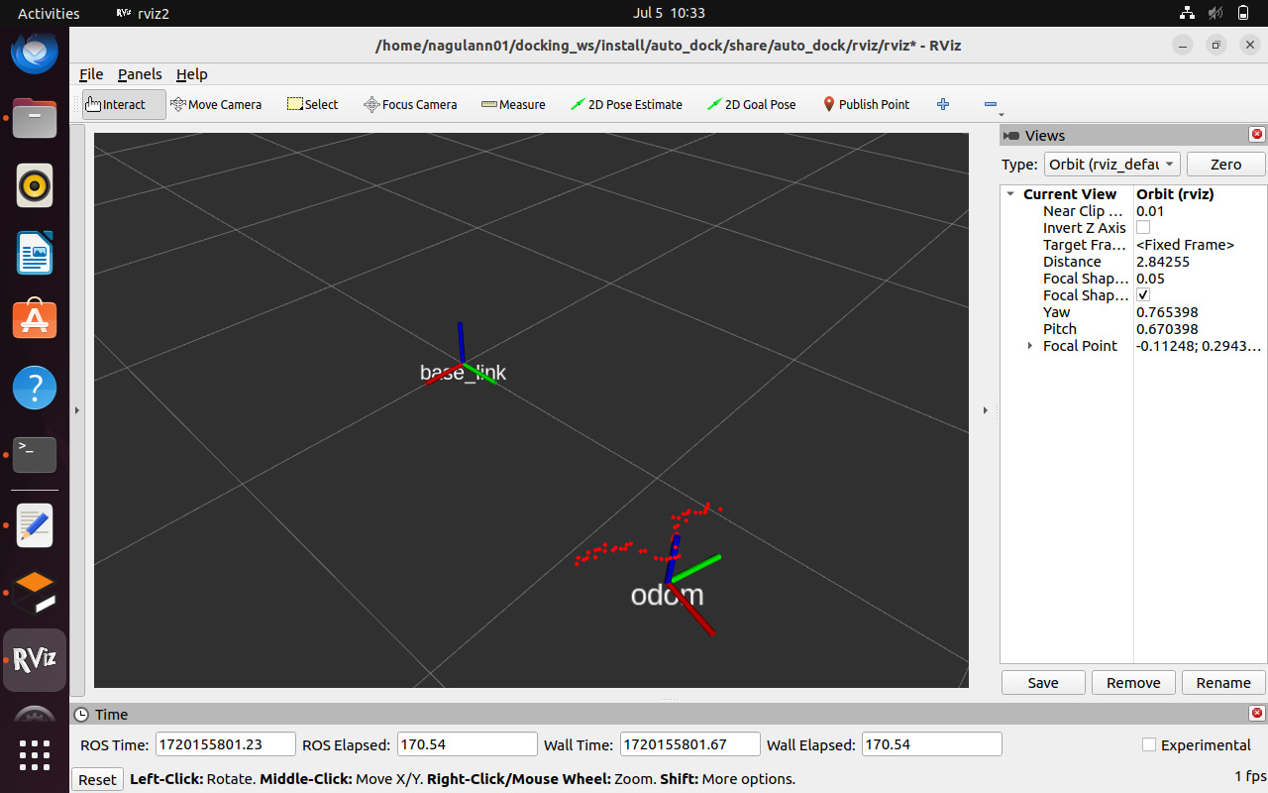

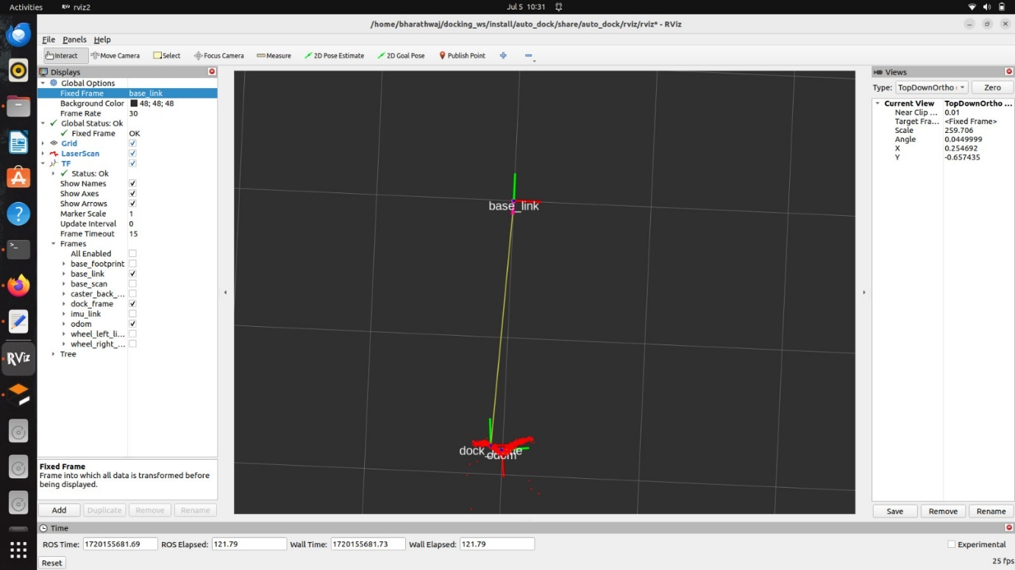

* The dock frame was not visible in RViz, indicating an error. By adjusting and increasing the resolution, the dock frame became visible.

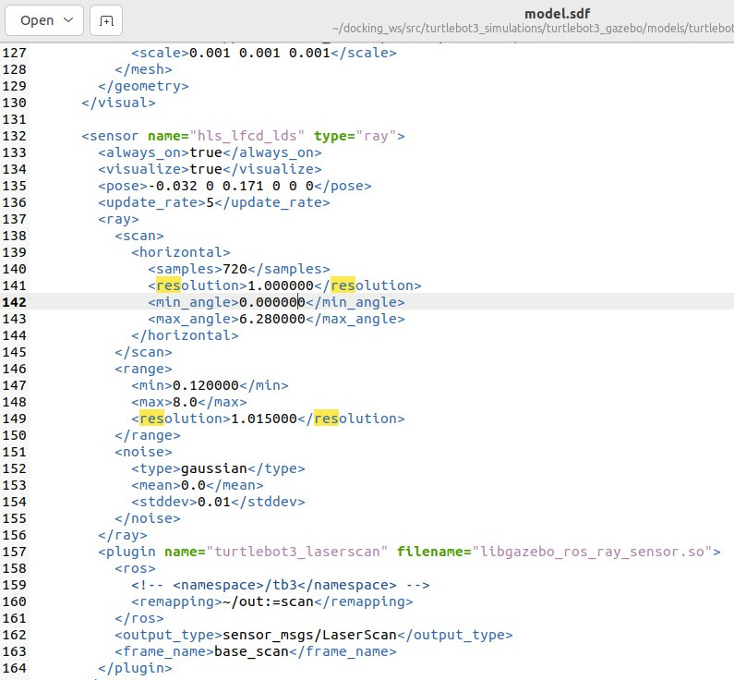

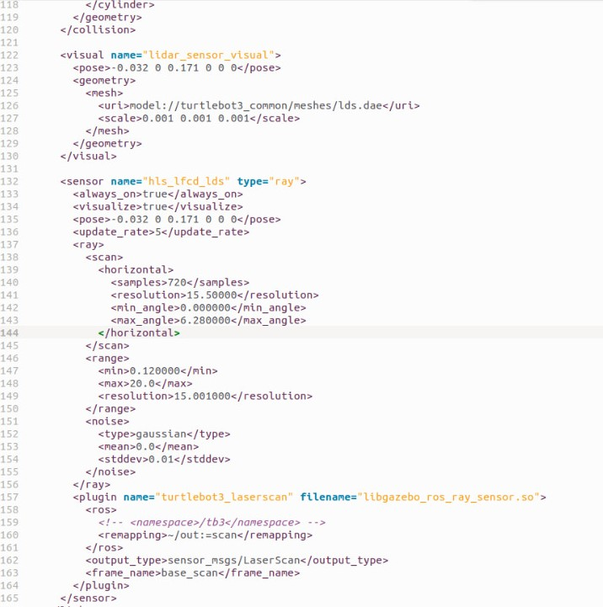

* We initially set the odom frame as the parent and the dock frame as the child, but the correct configuration is to have the base_link as the parent and the dock frame as the child.

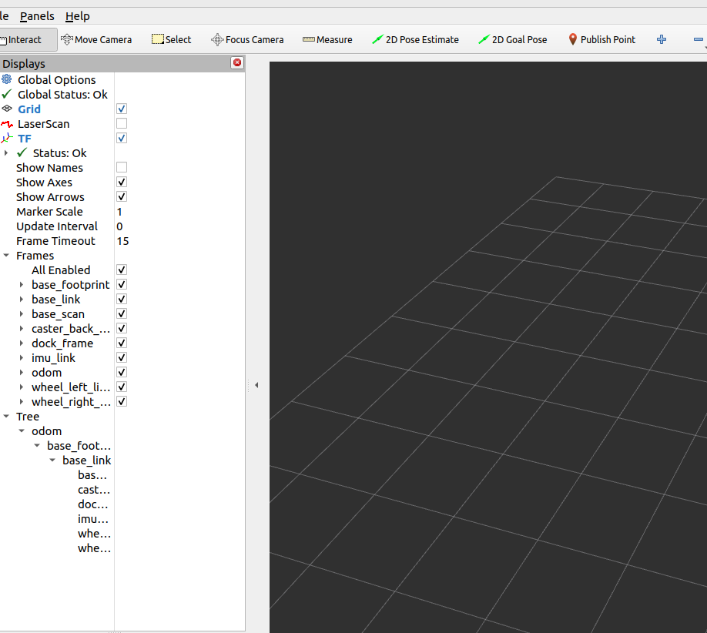

* Keep the max_angle above 17 to perfectly dock.

**FOLDER :**

Docking_ws

* src
  + automatic_parking
    - auto_dock
      * include
        + auto_dock.h
        + controller.h
        + pattern.h
      * launch
        + auto_humble.launch.py
      * rviz
        + rviz.rviz
      * src
        + controller.cpp
        + pattern.cpp
      * CMakeLists.txt
      * Package.xml
    - Model
      * + dock1

model.config

model.sdf

* + - * + dock2

model.config

model.sdf

* + - readme_resource
    - README.md
  + DynamixelSDK
    - * dynamixel_sdk

include

src

CHANGELOG.rst

CMakeLists.txt

Package.xml

* + - * dynamixel_sdk_custom_interfaces
      * dynamixel_sdk_examples
      * CONTRIBUTINH.md
      * Doxyfile
      * LICENSE
      * README.md
  + laser_line_extraction

build

images

include

line.h

line_extration.h

line_extraction_node.h

line_extraction_ros.h

install

laser_line_msgs

log

msg

src

line.cpp

line_extration.cpp

line_extract ion_node.cpp

line_extraction_ros.cpp

CMakeLists.txt

config

LICENSE

pakage.xml

README.md

* + laser_line_msgs

msg

LineSegmet.msg

LineSegmentList.msg

CMakeList.txt

pakage.xml

README.md

* + turtlebot3
  + turtlebot3_msgs
  + turtlebot3_simulations

turtlebot3_fake_node

Turtlebot3_gazebo

Turtlebot3_simulations

CONTRIBUTING.md

LICENSE

README.md

* Create workspace

Mkdir -p ~/docking_ws /src

* Copy and paste the package
* Source your ws

Source install/setup.bash

* Build your ws

Colcon build

* Launch your gazebo file

Ros2 launch turtlebot3_gazebo empty_world.launch.py

* Launch your auto dock file

Ros2 launch auto_dock auto_humble.launch.